MINERVINI
GROWTH STOCK STRATEGY
VCP · Stage 2 Analysis · Code 3 Fundamentals · Relative Strength
"Not losing big is the single most important factor for winning big." — Mark Minervini
Stage  Stage 2 Only | Pattern  VCP — Volatility Contraction | Fundamentals  Code 3: EPS + Sales + Margins | Priority  Risk Management First

1. Overview — The Minervini Approach
Mark Minervini is a US Investing Champion whose strategy combines precise technical timing with fundamental acceleration to identify the highest-probability growth stocks before their major price advances. The central objective is to "hit and not get hit" — capturing explosive upside from the strongest stocks while managing risk with discipline that most traders are unwilling to apply.

The strategy has three integrated components that must all align before a trade is taken: the stock must be in a Stage 2 uptrend, the technical pattern must show a Volatility Contraction Pattern (VCP) with a defined trigger bar, and the underlying fundamentals must show Code 3 acceleration. All three together — not just one or two.

💡 | Minervini studied the biggest winning stocks over decades and reverse-engineered their common characteristics before their major runs. The strategy is built from what actually worked historically — not theory. Every rule has a pattern behind it.

2. Stage Analysis — Only Trade Stage 2
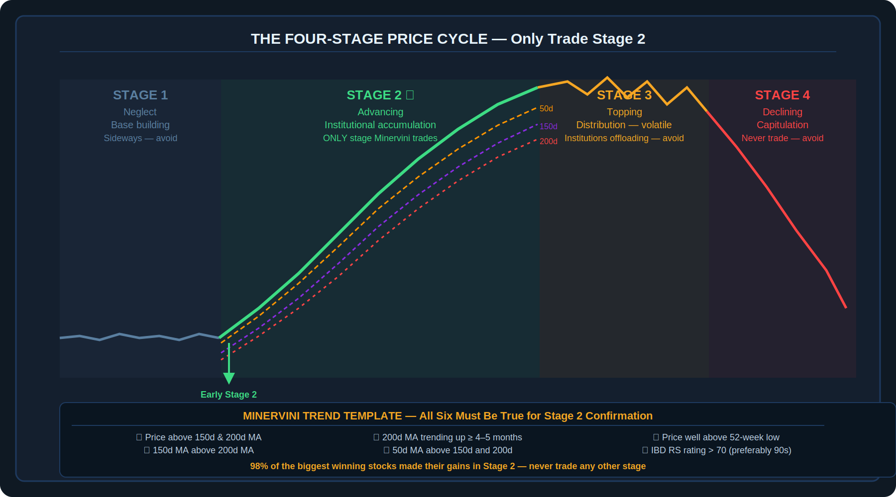
Diagram 1 — The Four-Stage Price Cycle: Stage 2 is the only stage where Minervini enters. The Trend Template confirms Stage 2.
Every stock moves through a predictable four-stage price cycle. Minervini's most important rule is simple: only trade Stage 2 stocks. Every other stage — neglect, topping, or declining — is explicitly avoided.

2.1 The Four Stages
Stage | Name | Characteristics | Minervini Rule
Stage 1 | Neglect | Flat base, sideways, low volume, under all MAs | Do not trade — no direction
Stage 2 | Advancing | Uptrend, institutional accumulation, higher highs | THE ONLY stage to trade
Stage 3 | Topping | Volatile, distribution, institutions offloading | Avoid — sell if held
Stage 4 | Declining | Downtrend, capitulation, below all MAs | Never trade — avoid

Research shows that 98% of the biggest winning stocks made the largest portion of their gains in Stage 2. Entering in Stage 1 means waiting for a move that may not come. Entering in Stage 3 means buying a topping market from institutions who are selling to you.

2.2 The Minervini Trend Template — Confirming Stage 2
To confirm a stock is in a valid Stage 2 uptrend, Minervini applies a six-part Trend Template. All six criteria must be met simultaneously:

Trend Template — All Six Required
- The share price is above both the 150-day (30-week) and 200-day (40-week) moving averages.
- The 150-day moving average is above the 200-day moving average.
- The 200-day moving average is trending upward for at least 4–5 months.
- The 50-day (10-week) moving average is above both the 150-day and 200-day moving averages.
- The current share price is well above its 52-week low — showing significant appreciation from the base.
- The IBD Relative Strength rating is greater than 70, preferably in the 90s (William O'Neill's research found the average RS rating at breakout was above 87).

📌 | A stock hitting 52-week highs while still building its base — before the breakout — is an extremely powerful signal. It means the stock is stronger than almost everything else in the market even during its consolidation. This is the proverbial basketball being held underwater.

3. The Volatility Contraction Pattern (VCP)
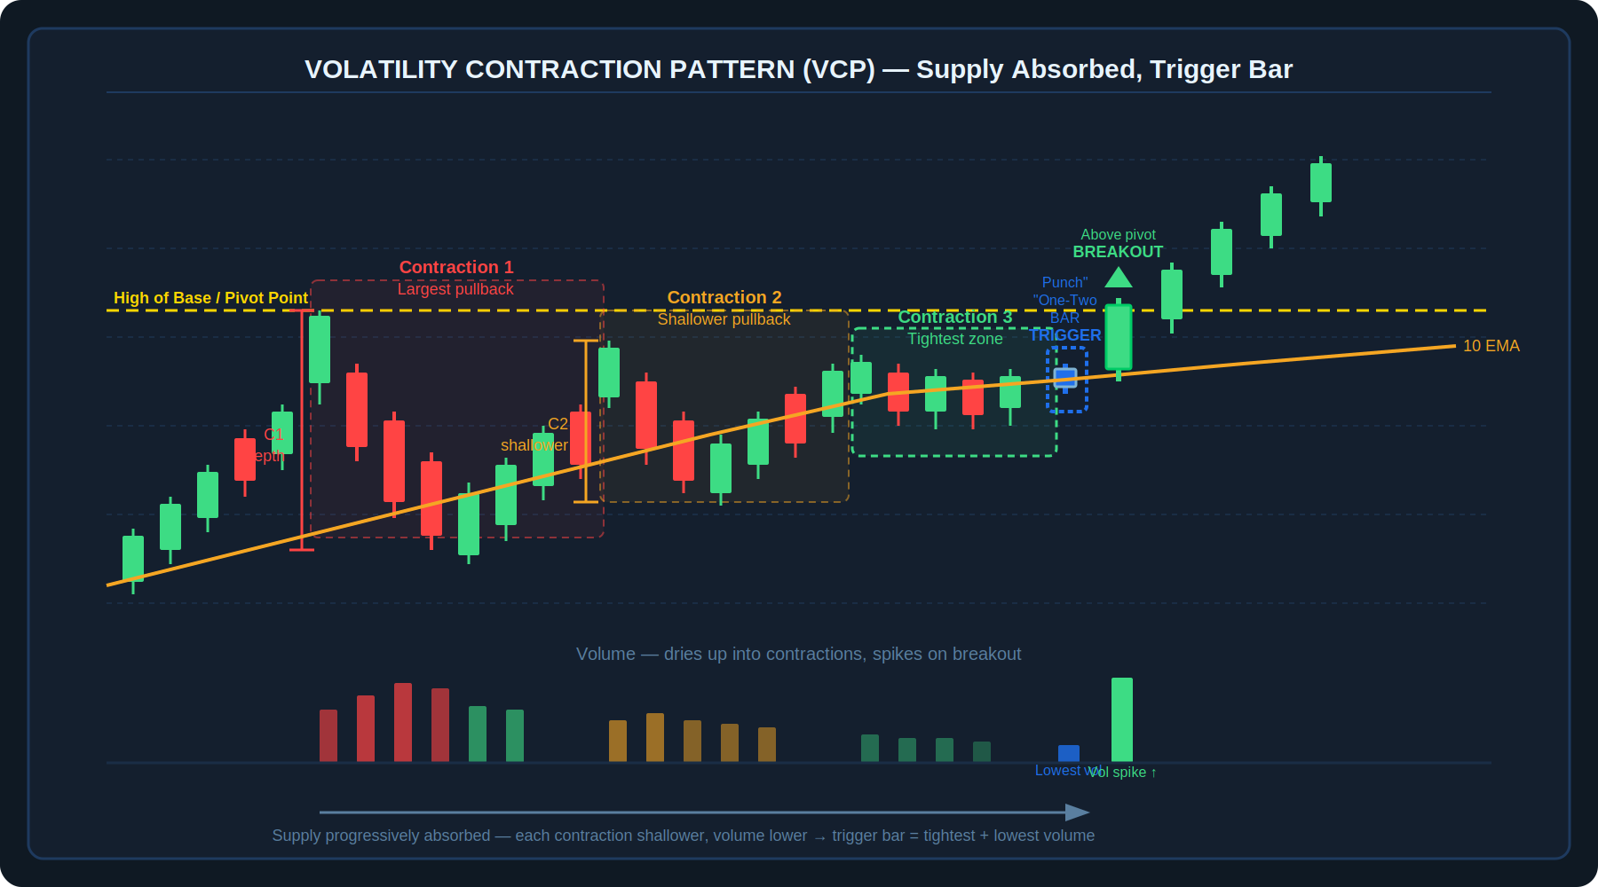
Diagram 2 — VCP: Three contractions each shallower than the last, volume drying up, culminating in the trigger bar ("one-two punch") at the 10 EMA before breakout
The VCP is the technical pattern Minervini uses to time entries within a Stage 2 stock. It represents supply progressively being absorbed from the market. Each successive pullback within the base is shallower than the prior one — less supply is available, and what remains is becoming exhausted. Volume contracts alongside price during this process, confirming that sellers are drying up.

3.1 The Contraction Sequence
A valid VCP shows a sequence of progressively tighter pullbacks from left to right within the base. Each contraction should be shallower in percentage depth than the one before it, and volume on each successive decline should be lower. The number of contractions varies — the important characteristic is the directionality: each one tighter than the last.

- First contraction: the largest pullback in the base. Sets the initial range.
- Second contraction: shallower. Volume lower. Fewer sellers remain.
- Third (or final) contraction: the tightest zone. Volume at or near the lowest level in the entire base. This is where the trigger bar forms.

3.2 The Trigger Bar — The "One-Two Punch"
The trigger bar is what Minervini calls the final piece of the jigsaw. It is an extremely tight daily candlestick — the tightest range in the entire base — formed on the lowest volume in the base. When this bar appears, it tells two things simultaneously:

- Supply is essentially gone from the market. There are virtually no more sellers at this level. Even a small amount of buying demand can push price sharply higher through a level with no overhead supply.
- Because the trigger bar is so tight, the stop loss can be placed very close below it — making the trade structurally efficient with excellent risk control.

The trigger bar should ideally form at or near the 10-day EMA. This serves two purposes: it confirms price is not overextended from the moving average (which would widen the stop), and it provides a logical structural reference for stop placement.

⚠️ | A stock where price is extended far above the 10 EMA — even with a tight trigger bar — has a wider effective stop and a less favourable risk/reward ratio. Minervini prefers to see the trigger bar sit near the 10 EMA so the stop can be placed tightly beneath both the bar and the moving average.

3.3 The Pivot Point and Breakout
The pivot point is the exact price level where the VCP ends and the breakout begins — the "line of least resistance." When price breaks above the pivot with a surge in volume, confirming that buyers have overwhelmed the remaining supply, this is the entry signal. A breakout accompanied by a 52-week high on the day is considered an exceptionally strong setup.

3.4 Chart Pattern Variations Using VCP Characteristics
VCP characteristics appear across multiple chart patterns, not just the classic VCP formation:

Pattern | Description | VCP Characteristic
Cup Completion Cheat (3C) | Entry before the handle forms or at the mid-base low. Allows early entry in strong stocks. | Tight consolidation forms inside the cup. Volume dries up. Early pivot opportunity.
Power Play (High Tight Flag) | Stock rallies very powerfully in a short period, then consolidates sideways with a shallow pullback and tight price action. | Extremely tight consolidation with volume contraction. Must respect 10 EMA. Very bullish structure.
Primary Base (Post-IPO) | The first significant basing pattern after an IPO. Often the highest-quality entry in a stock's lifecycle. | Same VCP contraction and trigger bar sequence. The first base is often the most powerful.
Classic VCP / Darvas Box | Multiple contractions forming a rectangular or staircase pattern within a base. | Each box tighter than prior. Volume staircase down. Trigger bar at the narrowest point.

📊 | Prior trend analysis matters. A stock that has been a smooth mover — consistently respecting its 10 and 21 EMAs during its prior advance — is more likely to continue doing so after the breakout. How a stock has behaved in the past is the best guide to how it will behave in the future. Stocks, like people, have personalities.

4. Relative Strength and Market Context
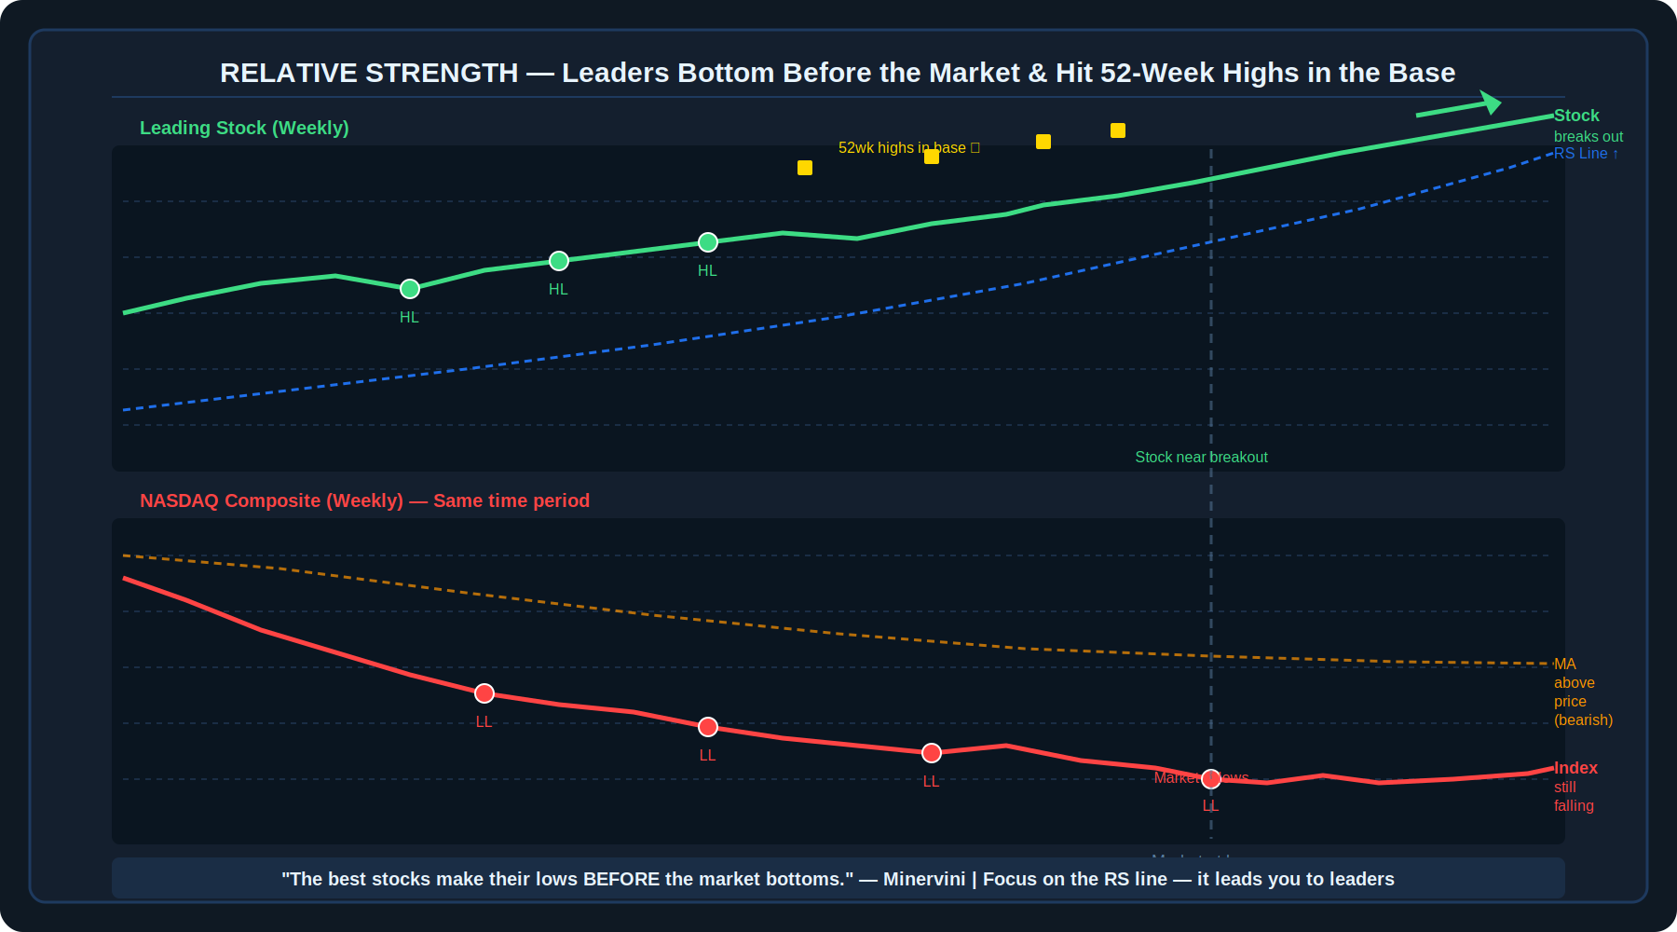
Diagram 3 — Leaders bottom and build higher lows while the index makes lower lows. RS line turns up during the base. 52-week highs in the base confirm extreme strength.
Minervini places enormous emphasis on Relative Strength (RS) — the measure of how a stock is performing relative to the overall market. The RS line plots a stock's price performance versus the benchmark index. When the RS line is rising, the stock is outperforming the market. When it hits new 52-week highs, the stock is in the top tier of performers.

4.1 Leaders Bottom Before the Market
One of the most powerful observations from Minervini's research: the biggest winning stocks consistently make their price lows before the overall market bottoms. While the NASDAQ Composite or other indexes are still making lower lows, true leaders are already building higher lows, consolidating above key moving averages, and hitting 52-week highs on their RS lines.

This is illustrated by legendary stocks like Amazon, eBay, Monster Beverage, Netflix, Tesla, and Amgen — each of which built their bases and began early Stage 2 moves while the general market was still declining. When the market eventually bottomed and began trending up, these stocks were released like a basketball held underwater — the removal of the market headwind allowed their pent-up strength to express fully.

4.2 The RS Line and 52-Week Highs in the Base
Relative Strength Signals to Prioritise
- RS line trending upward while the stock is still consolidating in its base = quiet leadership forming.
- RS line hitting 52-week highs while price is still in the base = the stock is a market leader even before the breakout.
- RS line hitting 52-week highs on the breakout day = extremely strong confirmation signal.
- Stock making higher lows while the index makes lower lows = resilience under market pressure.
- Stock holding above all key moving averages while the index is below its MAs = relative structural strength.
- Focus on the market's judgment — it does not miss the best opportunities. RS is how you find what the market has already identified as the strongest stocks.

4.3 The 91% Rule — Market Context
Research cited by Minervini shows that approximately 91% of successful VCP breakouts occur when the NASDAQ Composite is in a confirmed uptrend — specifically when it is trading above its monthly 10-period EMA. This means market timing matters. Breakouts attempted against a hostile general market have significantly lower odds.

🔑 | Trust the market's judgment. The biggest winning stocks in every era are identified in advance by their relative strength — their prices are already rising faster than everything else before their major moves begin. Chasing fundamentally interesting but technically weak stocks misses the point entirely.

5. Code 3 Fundamentals — The Engine Behind the Move
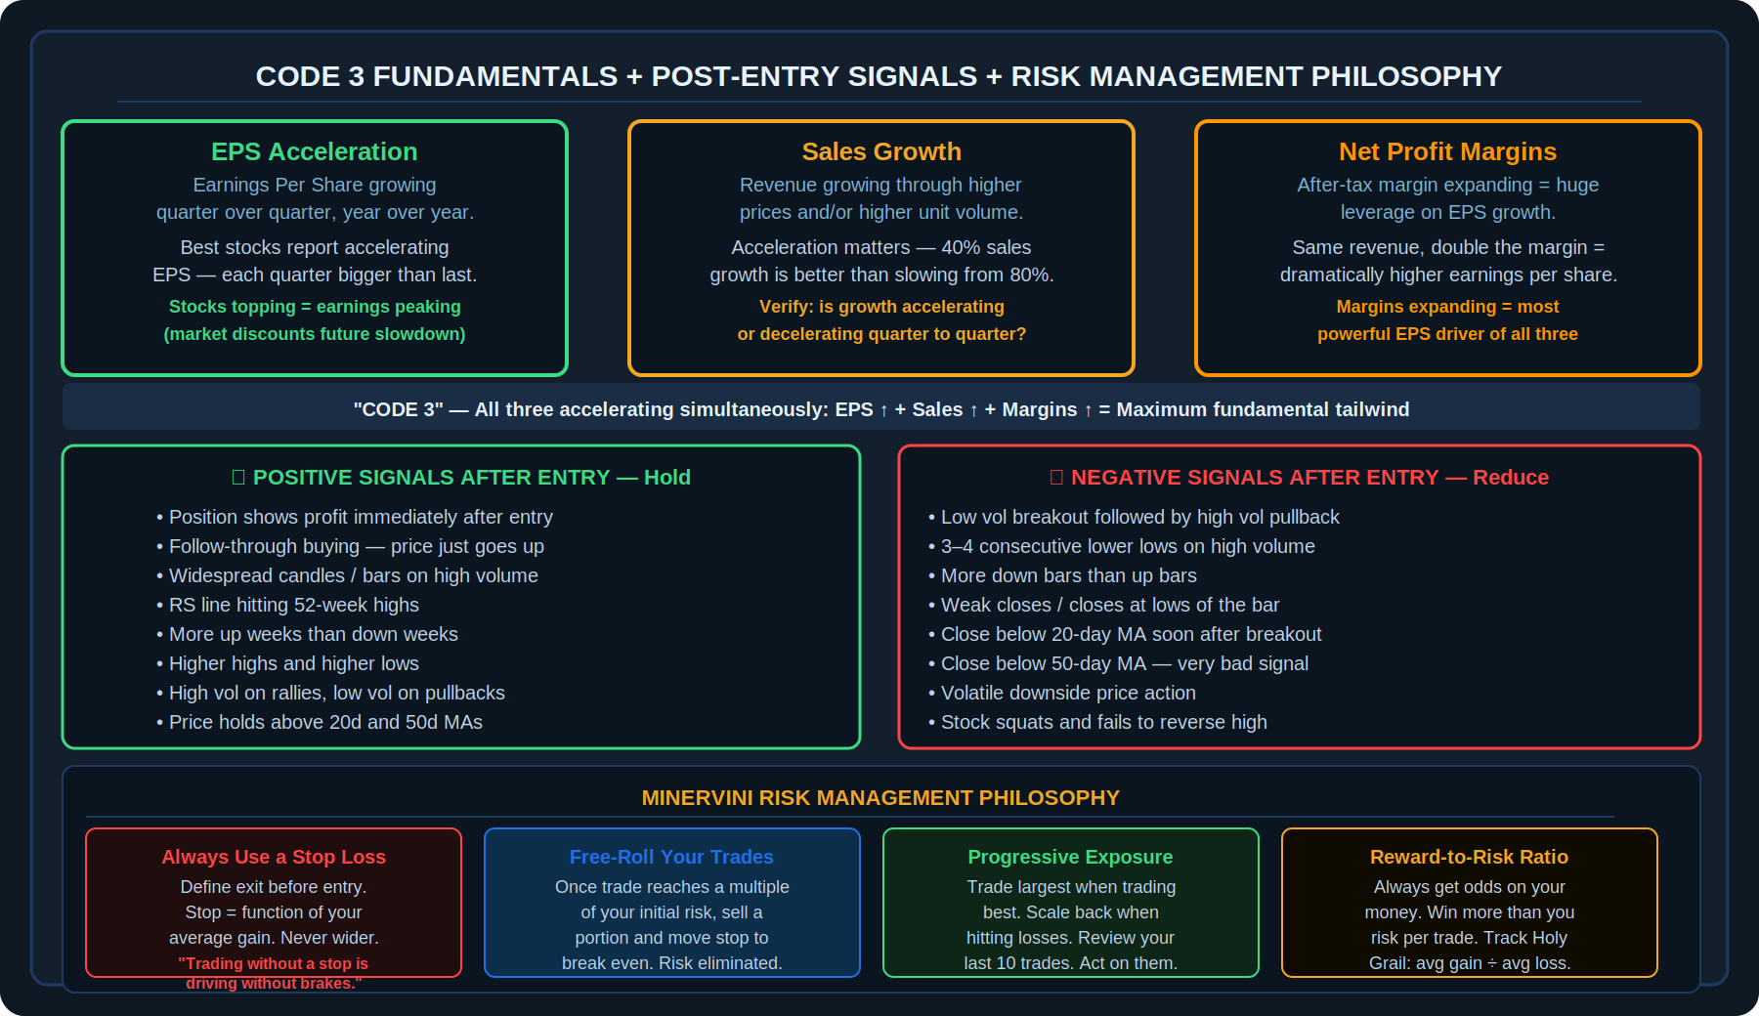
Diagram 4 — Code 3 (EPS + Sales + Margins), Post-Entry Signals, and Minervini Risk Management Philosophy
While the VCP and Stage 2 analysis time the entry, the fundamental picture determines whether the stock has the engine to produce a major move. Minervini focuses on three metrics that must all be accelerating simultaneously — he calls this "Code 3."

5.1 The Three Components of Code 3
- Earnings Per Share (EPS): Quarterly EPS should be growing year-over-year, and ideally accelerating — each quarter showing stronger growth than the prior one. The market rewards acceleration, not just high absolute numbers.
- Sales Growth: Revenue should be growing through higher prices and/or higher unit volume. As with EPS, acceleration is what matters — a company growing sales at an increasing rate is more valuable than one with high but slowing sales growth.
- After-Tax Net Profit Margins: This is arguably the most powerful of the three. When a company expands its profit margin, the effect on EPS is amplified dramatically — the same revenue generates a far higher profit, creating explosive earnings growth that the market prices in ahead of time.

📌 | Stocks very often top out while earnings still look excellent. The market is forward-looking — it begins pricing in a future deceleration of earnings before it appears in reported numbers. When a stock tops out at its highest reported earnings, it means the market has concluded that future earnings will be lower or slower. Monitor not just the level of earnings but the rate of change.

5.2 What to Look for in Earnings Reports
Minervini places particular emphasis on the market's reaction to earnings announcements for growth stocks. A strong positive gap on high volume after an earnings release is institutional accumulation in real time. This is one of the clearest signals that large operators have reviewed the fundamentals and are voting with capital.

- Look for large gap-ups on heavy volume after earnings — institutional accumulation in real time.
- Track the pattern: is the growth catalyst new? IPOs and companies with a new product, service, or market disruption tend to produce the biggest runs.
- Verify that earnings revisions are upward and guidance is positive — analysts increasing estimates after earnings is bullish.
- Be alert when earnings are still strong but the rate of growth is slowing. That deceleration, even from a high level, is often when the stock tops.

6. Managing the Trade — Post-Entry Signals and Selling

6.1 Positive Signals After Entry — Hold and Monitor
After a breakout, these signals confirm the trade is working and should be held:

Positive Post-Entry Signals
- Position shows a profit immediately after entry — price does not immediately return to the pivot.
- Follow-through buying — the stock continues moving up without reverting.
- Widespread candles on high volume coming through — institutional demand active.
- RS line hitting 52-week highs — stock continues to lead the market.
- More up weeks than down weeks, with strong closes on up bars.
- Higher highs and higher lows on the daily/weekly chart.
- High volume on rallies, low volume on pullbacks — healthy base-building action continues.
- Price holds above the 20-day and 50-day moving averages — structure intact.

6.2 Negative Signals After Entry — Reduce or Exit
These signals indicate the trade is not acting as expected and position reduction or exit should be considered:

Negative Post-Entry Signals
- Low volume on the breakout followed by high volume selling pulling back — fake breakout.
- Three to four consecutive lower lows on high relative volume — distribution underway.
- More down bars than up bars — downside pressure dominant.
- Weak closes — candles closing near their lows rather than their highs.
- A close below the 20-day moving average soon after the breakout — very bad signal.
- A close below the 50-day moving average soon after breakout — extremely bad signal.
- Volatile downside price action — institutional sellers present.
- Stock squats and fails to reverse back to the highs of the breakout day — failed setup.

6.3 Late-Stage Base Awareness
Not all bases in a Stage 2 uptrend carry equal risk. As a stock builds its third, fourth, and fifth base, the risk of being in a late-stage move increases significantly. Large operators who accumulated in the early bases have made substantial returns and are increasingly likely to be distributing (selling) into the strength of later rallies.

Late-stage bases can still produce profitable trades, but they require additional caution. The probability of a failed breakout or rapid price reversal increases materially after multiple prior bases. Minervini applies heightened scrutiny to any setup that is the fourth or fifth base in a Stage 2 cycle.

6.4 Sell Alerts — Signs of a Climactic Top
Sell Alerts — Consider Reducing or Exiting
- Accelerated or parabolic price advance — stock running up very rapidly after an already extended move.
- Stock moves up a large percentage in just one to three weeks after an extended prior advance.
- Largest up-day price spread since the beginning of the move — exhaustion buying.
- Churning action: high volume with little or no price progress — institutions selling into demand.
- Exhaustion gap after stock is already extended — typically the second or third gap in the move.
- New highs on declining volume — buyers becoming less aggressive at the highs.
- Heavy volume with a sharp drop below the 50-day moving average — institutional distribution.
- Largest single-day decline since the beginning of the move on high volume.
- Breaking out from a very late-stage base (4th, 5th, or later) after a long prior run.

7. Risk Management — The Foundation of the System
Minervini is unequivocal: risk management is the single most important concept in his entire system. Not pattern recognition, not fundamental analysis — risk management. The ability to stay in the game long enough to find the big winners depends entirely on not suffering losses that are too large to recover from.

📌 | "Not losing big is the single most important factor for winning big. As a speculator, losing is not a choice — but how much you lose is." — Mark Minervini. The goal is to control losses while allowing winners to run. This asymmetry — small losses, large gains — is where the edge lives.

7.1 Stop-Loss Philosophy
Every trade must have a defined stop loss before entry. This is non-negotiable. The stop loss is not set arbitrarily — it is a function of your average gain. If your typical winning trade produces a certain percentage gain, your stop loss must be meaningfully narrower than that gain to maintain a healthy reward-to-risk ratio. A stop wider than your average gain produces a negative expectancy system regardless of win rate.

- Define the exact stop loss price before placing any order. If you are not willing to accept the loss at that level, do not take the trade.
- The stop loss is placed at the level where the original trade thesis is invalidated — typically below the trigger bar, the contraction low, or the 10 EMA, depending on the setup.
- Never add to a losing position. Averaging down on a stock that is going against you violates the first principle of risk management.
- Move the stop loss up as the trade progresses and becomes profitable — never move it down to give a trade "more room."

7.2 The "Holy Grail" — Win Rate, Average Gain, Average Loss
Minervini refers to the relationship between these three statistics as the "Holy Grail" of trading performance. The formula is: (Average Gain × Win Rate) ÷ (Average Loss × Loss Rate) = Win/Loss Ratio. This ratio must be positive — and the higher, the better. A trader who is correct only 40% of the time can still be highly profitable if the average gain significantly exceeds the average loss.

Tracking this ratio across your last 10 trades is essential. It tells you whether the market is currently rewarding your strategy or not — and it determines whether you should be increasing or decreasing your exposure.

7.3 Free-Rolling — Eliminating Risk on Open Positions
Once a trade has moved in your favour by a meaningful amount relative to your initial risk, Minervini advocates "free-rolling" the position — selling a portion of the trade and moving the stop loss to reduce or eliminate the original risk. The exact mechanics are part of your personal trade management system, but the principle is consistent: as the trade works, progressively improve your worst-case scenario.

- The goal is to position yourself beyond the possibility of a significant loss on any trade that was once in meaningful profit.
- Selling a portion of the position locks in gains while the stop trail on the remainder protects the remaining profit.
- Free-rolling transforms a trade from pure risk into a situation where even the worst case still involves keeping some of the gains.

7.4 Progressive Exposure
Minervini's progressive exposure principle is about calibrating how much capital you deploy based on how well your strategy is currently working. When the market is rewarding your trades — when breakouts are following through, gains are accumulating, and your last several trades have been profitable — that is the time to be more fully invested. When the market is not rewarding your strategy — when breakouts are failing, stops are being hit repeatedly, and your recent trades are negative — that is the time to scale back significantly.

- Review your last 10 trades regularly. This rolling scorecard tells you more about your current edge than any analysis of the general market.
- Scale up aggressively on the heels of success when the market is in sync with your strategy.
- Scale back to minimal exposure during hostile market conditions — there is no shame in being mostly in cash when the environment is not favourable.
- Never increase position sizes in an attempt to recover losses from a bad streak. This is one of the most common causes of account damage.

8. Minervini's Trading Rules
14 Trading Rules
- Always trade with a stop loss — define your exit at a loss before you get in.
- Never add to a losing position. Averaging down is how losers average losses.
- Scale up when trading well. Scale down when trading poorly.
- Only go overweight a position in the direction of the trade. Cut overweight if it moves against you quickly.
- Consider trimming if the stock fails to move as expected after entry.
- Never hold a large position into a major earnings report without hedging the risk.
- Never let a good-sized gain turn into a loss. Move stop to break even as soon as practical.
- Position yourself beyond the possibility of defeat — free-roll winning trades.
- When there is a material change in behaviour (character change), sell immediately.
- Look for follow-up buying after a breakout. Lack of follow-through is an early warning.
- Do not have favourites. Do not marry stocks — just date them.
- Buy stocks in order of breakout strength and relative strength, not narrative or attachment.
- Always think in terms of risk versus reward before every single decision.
- Evaluate your positions every day. The market gives you new information daily — use it.

9. Pre-Trade Checklist
✓ | Checklist Item
☐ | Stage 2 confirmed: stock is in a clear uptrend with higher highs and higher lows
☐ | Trend Template: all six criteria are met (price above 150d and 200d, 150d above 200d, 200d trending up 4+ months, 50d above 150d and 200d, price well above 52-week low, RS > 70)
☐ | VCP identified: base shows progressively shallower contractions from left to right
☐ | Volume has dried up during the contractions — confirming supply absorption
☐ | Trigger bar present: the tightest daily range in the base on the lowest volume, at or near the 10 EMA
☐ | Pivot point defined: the exact breakout level is identified
☐ | Stop loss defined: placed below the trigger bar/10 EMA before order is placed
☐ | Reward-to-risk ratio is acceptable based on my recent average gain statistics
☐ | RS line is trending up or hitting 52-week highs — stock is a market leader
☐ | 52-week highs on the RS line confirm this is among the strongest stocks in the market
☐ | Code 3 confirmed: EPS accelerating, Sales accelerating, Margins expanding
☐ | Earnings reaction: the stock's response to the most recent earnings report was positive (gap-up on high volume)
☐ | Market context: NASDAQ Composite is in a confirmed uptrend (above its monthly 10 EMA)
☐ | No late-stage base risk: this is not the 4th or 5th base in an already extended Stage 2 cycle
☐ | Progressive exposure check: my last 10 trades support increasing, not decreasing, exposure right now

10. Key Terms
Term | Definition
Stage 2 Uptrend | The advancing phase of the four-stage price cycle. Characterised by higher highs and higher lows, institutional accumulation, and price above all key moving averages. The only stage Minervini trades.
Trend Template | Minervini's six-criteria checklist used to confirm a stock is in a valid Stage 2 uptrend before considering any entry.
Volatility Contraction Pattern (VCP) | A base pattern where price pullbacks become progressively shallower and volume declines with each contraction, indicating supply is being systematically absorbed before a breakout.
Contraction | A pullback within the base. VCP contractions must be progressively shallower (less deep in percentage terms) and on declining volume from left to right.
Trigger Bar / One-Two Punch | The final candlestick in a VCP — the tightest daily range and lowest volume in the entire base — which signals that supply has been virtually exhausted and price is ready to break out.
Pivot Point | The exact price level at the top of the VCP where the breakout occurs. The "line of least resistance." Entry is taken when price breaks above this level.
Code 3 | Minervini's term for simultaneous acceleration in all three fundamental metrics: Earnings Per Share (EPS), Sales, and After-Tax Net Profit Margins.
Relative Strength (RS) | A measure of how a stock's price is performing relative to the overall market. An RS line that is rising or hitting 52-week highs signals market leadership.
IBD RS Rating | A score from 1 to 99 ranking a stock's price performance against all other stocks. Minervini looks for scores above 70, preferably in the 90s.
52-Week High (in the base) | When a stock's RS line hits a new 52-week high while price is still consolidating in its base — an extremely bullish signal indicating elite relative strength.
Cup Completion Cheat (3C) | An entry technique that allows a trader to buy a stock at a low-cheat or mid-base pivot before the handle forms, enabling earlier entry in very strong setups.
Power Play (High Tight Flag) | A setup where a stock makes a very large rally in a very short period of time and then consolidates tightly with minimal pullback — indicating exceptional strength.
Primary Base | The first significant basing pattern a stock forms after its IPO — often the highest-quality and most powerful base in the stock's lifecycle.
Progressive Exposure | Minervini's capital deployment approach: increase position sizes and market exposure when trading well; scale back significantly when hitting a losing streak.
Free-Rolling | Selling a portion of a winning trade and moving the stop loss to reduce or eliminate the original risk, so the remaining position is effectively trading for free.
Late-Stage Base | The third, fourth, or fifth base in a Stage 2 cycle. Carries higher failure risk because large operators from early bases are increasingly likely to distribute.
Holy Grail (Trading) | Minervini's term for the mathematical relationship between average gain, win rate, and average loss. The ratio must be positive for a system to be profitable over time.

Disclaimer
This document is produced solely for educational and informational purposes. The strategy and framework described herein is based on publicly available information about Mark Minervini's trading approach, as shared through books, interviews, and educational content. This document is not affiliated with or endorsed by Mark Minervini. Trading in financial markets involves substantial risk of loss. Nothing in this document constitutes financial advice or a recommendation to trade. Always conduct your own due diligence and consult a qualified financial adviser before committing real capital.

