MARTIN LUKE
HIGH-MOMENTUM SWING TRADING
Trend Following, Tight Stops, and a Low Win Rate That Still Wins
"340% Return, Feb–Dec 2024" | ADR > 5% | 23% Win Rate, High R-Multiples
Influences  Minervini & Kullamägi (VCP/Breakout) | Target Stocks  ADR > 5% ("Horse Center") | Risk Per Trade  0.5% of Portfolio | Max Stop  5% (hard ceiling)

1. Overview — Trend Following on Fast-Moving Stocks
Martin Luke's swing trading strategy produced a 283% account return in 2024 (340% specifically across the February-to-December stretch), built on trend following and catching high-momentum, fast-moving stocks. His approach is explicit about NOT trying to predict where a stock will go — instead, risk is managed through tight, precisely placed stops, and profits come from letting winners run with strong reward-to-risk asymmetry.

The strategy draws its core philosophy from two well-known growth-stock traders: Mark Minervini's breakout methodology and Christian Kullamägi's Volatility Contraction Pattern (VCP) approach. Both emphasise buying strength as it breaks out of a well-formed base, rather than buying weakness or trying to predict a bottom.

💡 | The defining mathematical feature of this strategy is a deliberately LOW win rate (around 23%) offset by a HIGH reward-to-risk ratio. This is not a flaw to fix — it is the engine of the strategy. Most trades lose a small, controlled amount; a minority of trades produce outsized gains that more than make up for the rest.

2. Stock Selection — The "Horse Center"
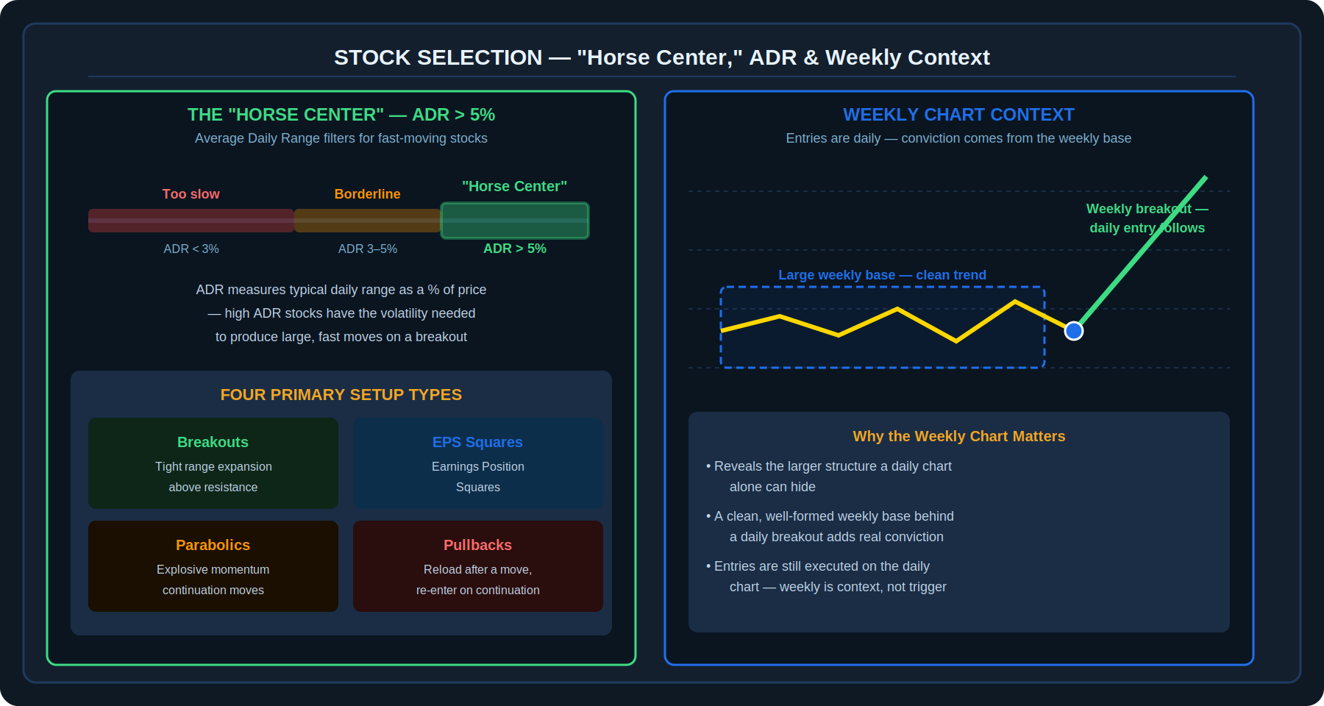
Diagram 1 — The ADR filter ("horse center" at ADR > 5%), the four primary setup types, and how the weekly chart provides conviction for daily entries

2.1 Average Daily Range (ADR) Filter
Luke specifically targets stocks in what he calls the "horse center" — stocks with an Average Daily Range (ADR) greater than 5%. ADR measures a stock's typical daily price range as a percentage of its price, and a high ADR is a direct proxy for the volatility needed to produce the fast, explosive moves this strategy is built to capture. Lower-ADR stocks simply do not move fast enough to generate the reward-to-risk asymmetry the strategy depends on.

2.2 Weekly Chart Context
While all entries are executed on the daily chart, Luke uses the weekly chart specifically to identify large bases and clean overall trends. A daily breakout that occurs against the backdrop of a large, well-formed weekly base adds significant conviction to the trade — it suggests the move is breaking out of genuine longer-term consolidation rather than a short-term, less reliable pattern visible only on the daily timeframe.

2.3 Four Primary Setup Types
The Core Setups
- Breakouts: Range expansion above a resistance level, typically following a period of tightening price action.
- Earnings Position Squares (EPS): Setups specifically tied to a stock's positioning around earnings events.
- Parabolics: Explosive, fast-accelerating continuation moves — entered with the awareness that these can reverse sharply.
- Pullbacks: Re-entry opportunities after an initial move, buying continuation rather than chasing the original breakout.

3. Tightness, Inside Days, and Entry Tactics
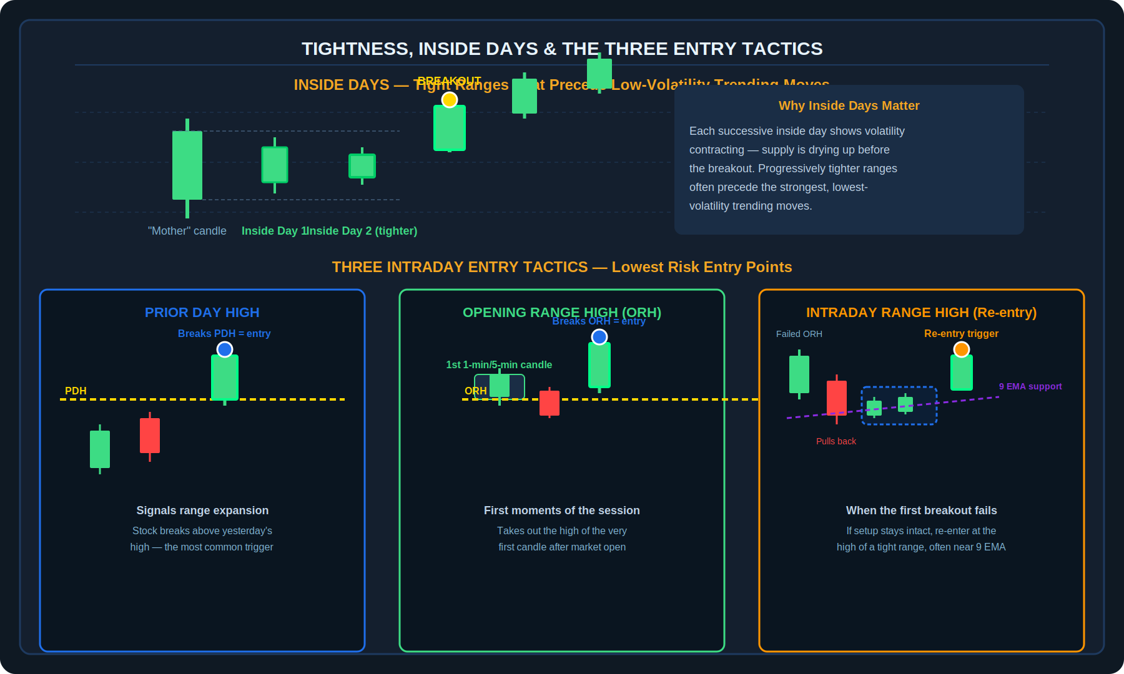
Diagram 2 — Inside days showing volatility contraction before a breakout, and the three intraday entry tactics: Prior Day High, Opening Range High, and Intraday Range High re-entry

3.1 Tight Ranges and Inside Days
Luke places heavy emphasis on tight price ranges in the period immediately before a breakout. Specifically, he looks for inside days — days where the entire daily range falls within the previous day's range. A sequence of inside days, especially with each successive day tighter than the last, often precedes the strongest, lowest-volatility trending moves, because it reflects supply drying up before the breakout.

3.2 Three Intraday Entry Tactics
Finding the Lowest-Risk Entry Point
- Prior Day High (PDH): The most common trigger — entering when a stock breaks above the previous day's high, signalling range expansion and the start of a potential new move.
- Opening Range High (ORH): Entering when a stock takes out the high of the first 1-minute or 5-minute candle of the trading session — capturing momentum right from the open.
- Intraday Range High (Re-entry): If an initial ORH breakout attempt fails but the overall setup remains structurally intact, Luke looks for a re-entry at the high of a subsequent tight intraday range, often with support from the 9 EMA underneath.

4. Risk Management — The Engine of the Strategy
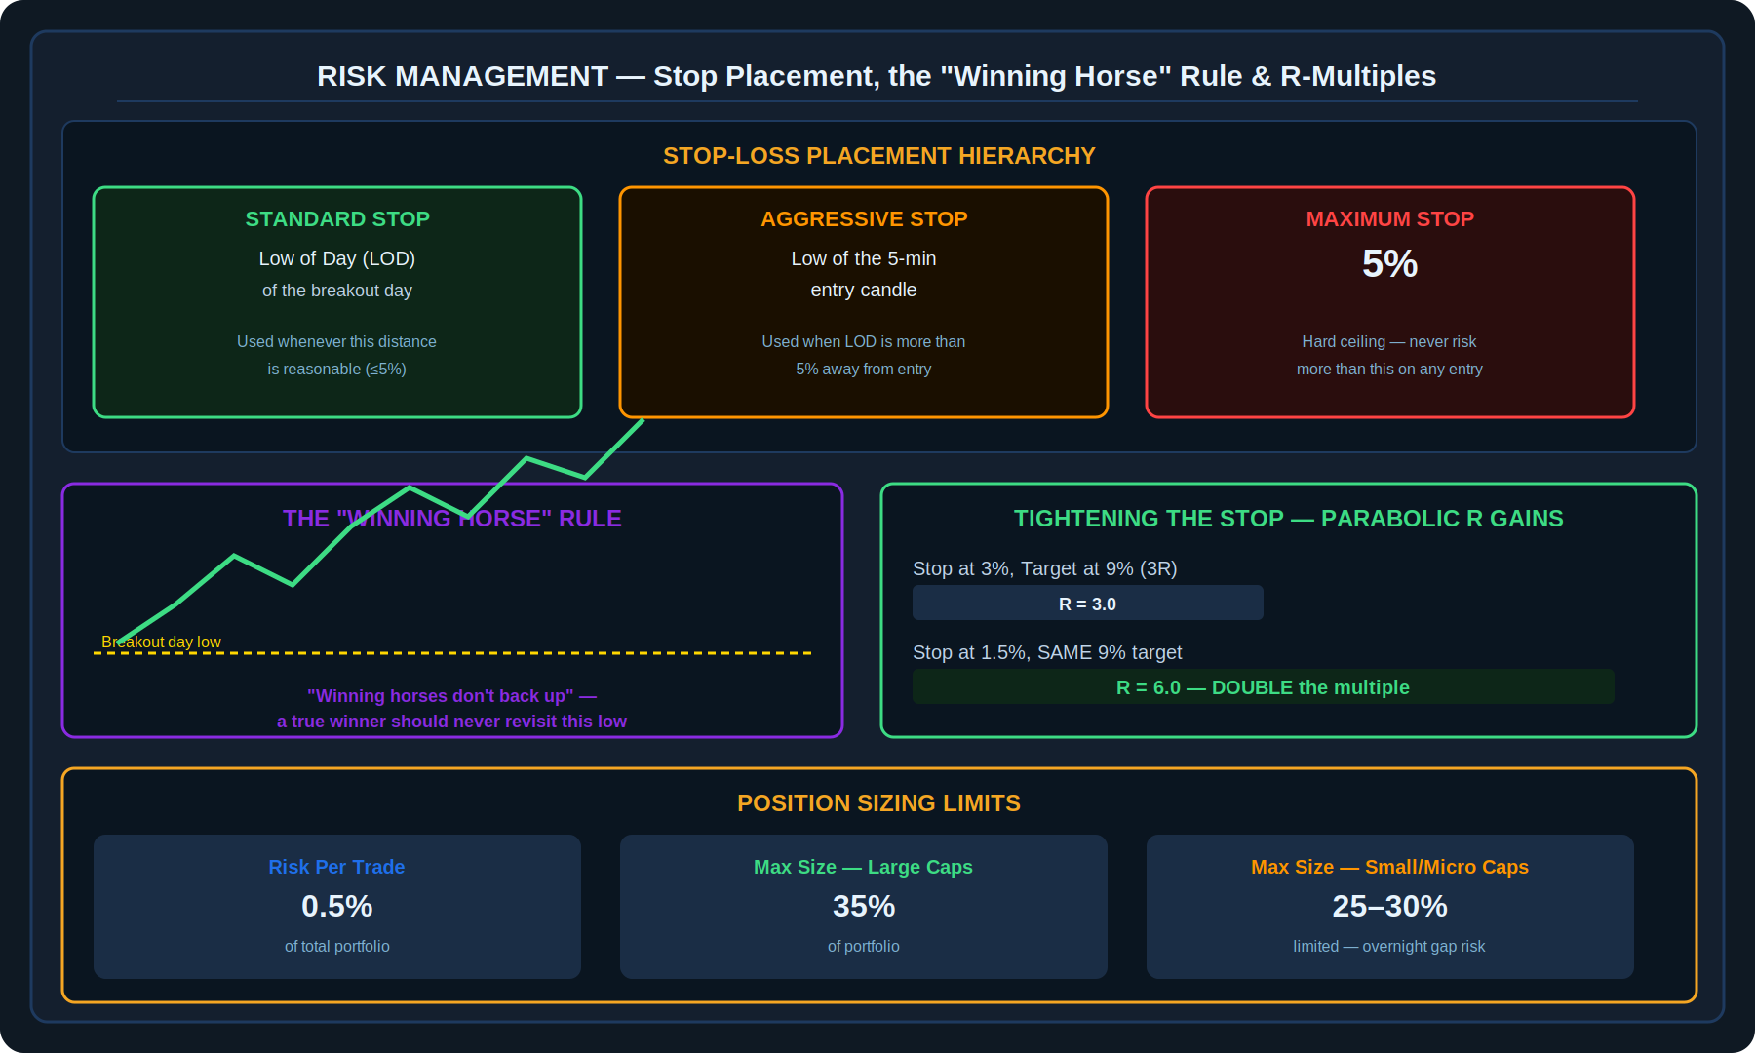
Diagram 3 — Stop placement hierarchy, the "Winning Horse" rule, how tightening a stop parabolically increases the R-multiple, and position sizing limits

4.1 Stop-Loss Placement Hierarchy
Three-Tier Stop Placement
- Standard Stop: The Low of Day (LOD) of the breakout day — the default choice whenever this distance from entry is reasonable.
- Aggressive Stop: If the LOD is more than 5% away from entry, Luke instead uses the low of the 5-minute entry candle — a much tighter reference point.
- Maximum Stop: Regardless of which method is used, the stop is generally capped at 5% — this is a hard ceiling, not a target.

4.2 The "Winning Horse" Rule
Luke operates on the principle that "winning horses don't back up" — meaning that if a stock is a genuine winner, it generally should not revisit the low of its breakout day. This rule functions as both a filter (a stock repeatedly testing its breakout-day low is showing weakness, not strength) and a piece of conviction-building logic for staying in a position that is behaving as a true winner should.

"Winning horses don't back up."
— Martin Luke

4.3 Tightening Stops for Parabolic R-Gains
Luke prioritises entries that offer high potential risk multiples (R). The relationship between stop distance and R-multiple is not linear — tightening a stop from 3% to 1.5% (holding the target distance constant) DOUBLES the resulting R-multiple, since R is defined as reward divided by risk. A smaller, well-placed stop is therefore one of the most direct levers available for improving a trade's risk-adjusted potential, independent of where the stock actually ends up going.

4.4 Position Sizing
Parameter | Specification
Risk Per Trade | 0.5% of total portfolio
Max Position — Large Caps | 35% of portfolio
Max Position — Small/Micro Caps | 25–30% of portfolio (lower, due to overnight gap-down risk)

5. The EMA System — Trailing Longs and Identifying Shorts
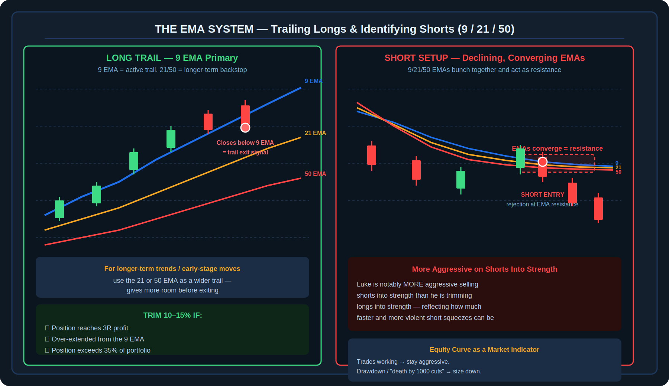
Diagram 4 — Left: 9 EMA as the primary long trail with 21/50 as longer-term backstops. Right: declining, converging EMAs forming resistance for short setups

5.1 Trailing Longs
Luke uses the 9 EMA as his primary trailing stop for long positions — as long as the stock continues closing above the 9 EMA, the position is held. For longer-term trends or earlier-stage moves where more room is appropriate, he shifts to the 21 or 50 EMA as a wider trailing reference instead.

5.2 Trimming Into Strength
Trim 10–15% of a Position If:
- The position reaches 3R profit (three times the original risk).
- The stock becomes significantly over-extended from the 9 EMA.
- The position has grown beyond 35% of the total portfolio (organically, through appreciation).

5.3 Short Selling — Declining, Converging EMAs
Luke's short strategy looks for the inverse structural signature: the 9, 21, and 50 EMAs declining and converging together, forming a tight band that then acts as resistance on any bounce attempt. Notably, Luke is described as significantly MORE aggressive selling shorts into strength than he is trimming longs into strength — reflecting the generally faster, more violent nature of short-side moves and squeezes.

6. Technical Tools and Equity Curve Feedback
Luke keeps his charts deliberately clean, relying on a small, consistent toolkit:

- Exponential Moving Averages: the 9, 21, and 50 EMA — used for trend identification, trailing stops, and short-side resistance.
- Volume: specifically dollar volume (price × shares traded) rather than raw share volume, which better reflects genuine capital flow.
- Anchor VWAP: used as an additional reference for institutional-level support/resistance and fair value.

Beyond technical tools, Luke treats his own equity curve as a market indicator in its own right. If his trades are working — meaning the broader market environment is favourable for his style — he stays aggressive. If he finds himself in a drawdown, experiencing what he calls "death by a thousand cuts," that is itself a signal to systematically reduce position size rather than fight through the difficult stretch at full size.

🔑 | This is a meta-risk-management layer on top of the per-trade rules: the strategy adapts its overall aggressiveness based on how well it is currently performing, rather than applying the same size and conviction in every market environment.

7. Daily Routine and Scanning Workflow
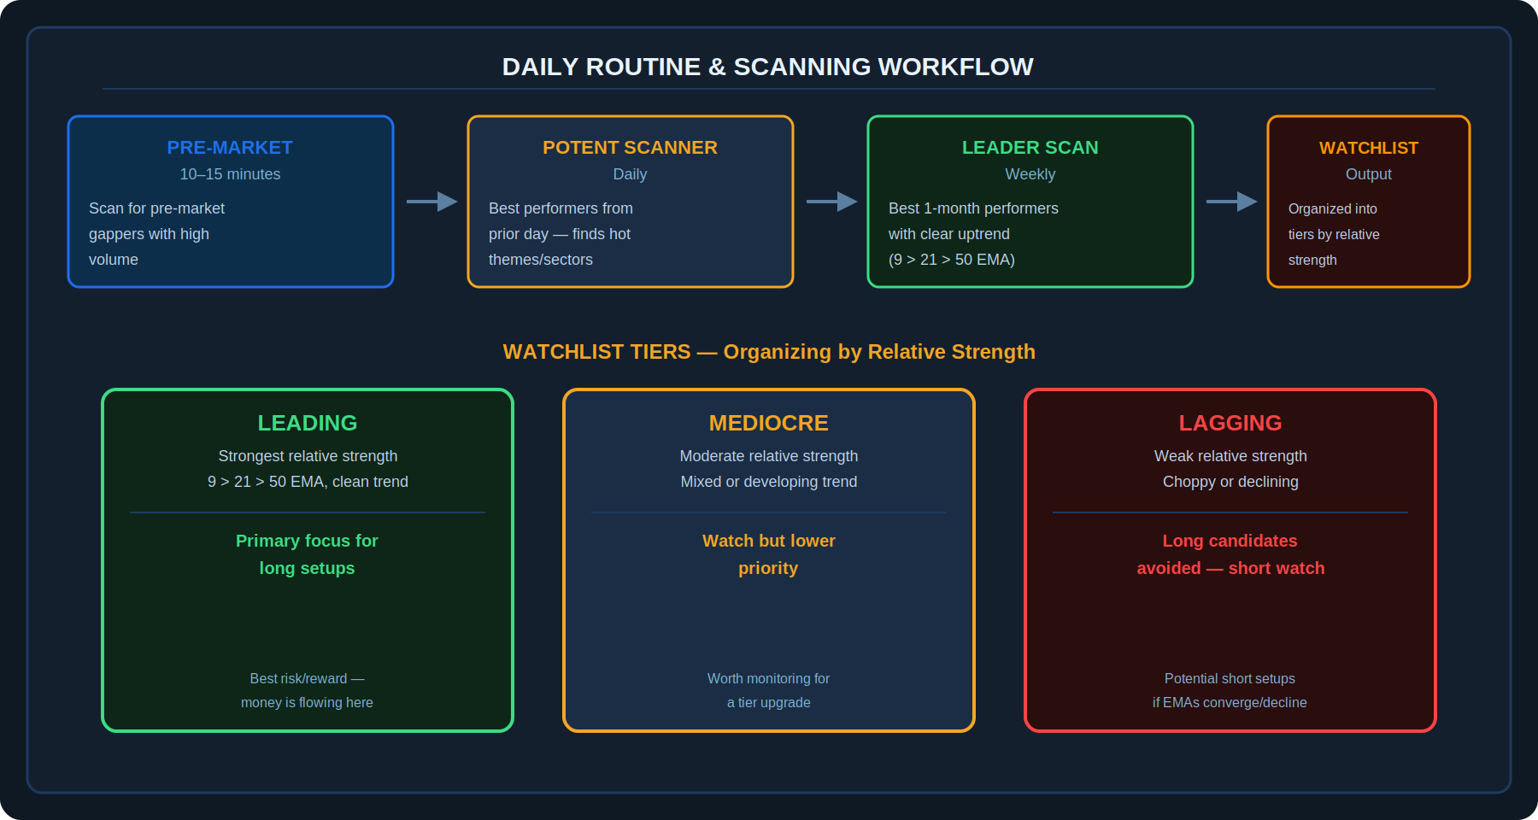
Diagram 5 — The daily scanning workflow (pre-market gappers → Potent Scanner → weekly Leader Scan) feeding into a three-tier watchlist
The Scanning Process
- Pre-Market (10–15 minutes): Scans for pre-market gappers showing high volume — the first pass for the day's candidates.
- Potent Scanner: Identifies the best-performing stocks from the previous trading day, used to find hot themes or sectors where capital is currently flowing.
- Leader Scan (Weekly): A weekly process to find stocks with the best performance over the trailing month that also display a clear uptrend structure (9 EMA above 21 EMA above 50 EMA).

7.1 Watchlist Tiers
Output from the scanning process is organised into three tiers based on relative strength, helping prioritise where attention and capital should go:

Tier | Description
Leading | Strongest relative strength, clean uptrend structure (9 > 21 > 50 EMA). Primary focus for long setups — best risk/reward, capital actively flowing in.
Mediocre | Moderate relative strength with a mixed or still-developing trend. Worth monitoring for a potential tier upgrade, but lower priority for new capital.
Lagging | Weak relative strength, choppy or declining structure. Long setups generally avoided here; these names are instead monitored as potential short candidates if EMAs converge and decline.

8. Pre-Trade Checklist
✓ | Checklist Item
☐ | The stock has an Average Daily Range (ADR) greater than 5%
☐ | The weekly chart shows a large, clean base or trend behind the setup
☐ | The setup matches one of the four primary types: breakout, EPS, parabolic, or pullback
☐ | Price action shows tightening ranges, ideally one or more inside days, ahead of the move
☐ | Entry is triggered by Prior Day High, Opening Range High, or (on re-entry) an Intraday Range High
☐ | Stop loss is set at the Low of Day, or the 5-minute entry candle low if LOD exceeds 5%, with an absolute maximum of 5%
☐ | Position size is calculated to risk 0.5% of total portfolio on this trade
☐ | Position size does not exceed 35% (large cap) or 25–30% (small/micro cap) of total portfolio
☐ | I have evaluated the resulting R-multiple — am I getting the tightest reasonable stop relative to my target?
☐ | I am aware of my current equity curve state and have sized accordingly (aggressive if working, reduced if in drawdown)
☐ | This stock currently sits in my "Leading" watchlist tier, or I have a specific reason to act on a Mediocre/Lagging name

9. Key Terms
Term | Definition
Average Daily Range (ADR) | A measure of a stock's typical daily price range expressed as a percentage of price. Luke targets stocks with ADR greater than 5% — the "horse center."
Volatility Contraction Pattern (VCP) | A base pattern (associated with Christian Kullamägi and Mark Minervini) where price pullbacks become progressively shallower before a breakout, reflecting supply drying up.
Inside Day | A trading day whose entire price range falls within the range of the previous day, signalling contracting volatility.
Prior Day High (PDH) | The high of the previous trading session — a common breakout trigger level.
Opening Range High (ORH) | The high of the first 1-minute or 5-minute candle after the market opens, used as an early-session breakout trigger.
Low of Day (LOD) | The lowest price reached during a given trading session — used as the standard stop-loss reference for breakout entries.
R-Multiple | A trade's profit or loss expressed as a multiple of the initial risk taken. A tighter stop (for the same target) produces a higher R-multiple.
Winning Horse Rule | Luke's principle that a genuine winning stock should not revisit the low of its breakout day — used as both a filter and a conviction check.
9 / 21 / 50 EMA | Exponential Moving Averages used as the core trend and trailing-stop framework — 9 EMA as the primary tight trail, 21/50 as wider, longer-term references.
Anchor VWAP | A Volume-Weighted Average Price calculation anchored to a specific starting point (such as an earnings date or breakout day), used as a institutional-level reference level.
Potent Scanner | A daily scanning tool used to identify the previous day's best-performing stocks, surfacing hot themes or sectors.
Leader Scan | A weekly scanning process identifying stocks with the strongest one-month performance and a clear EMA-based uptrend structure.
Watchlist Tiers | A three-level classification (Leading, Mediocre, Lagging) used to organise candidate stocks by relative strength and prioritise capital allocation.
Equity Curve Feedback | Using one's own recent trading performance as a signal for how aggressively to size new trades — scaling up when performing well, scaling down during drawdowns.

Disclaimer
This document is produced solely for educational and informational purposes, based on publicly shared commentary attributed to a trader known as Martin Luke. This document is not affiliated with or endorsed by Martin Luke. The performance figures cited (283%/340% returns, 23% win rate) are historical results attributed to a specific individual and are not representative of typical results. Nothing in this document constitutes financial advice, a recommendation to trade, or a guarantee of any specific outcome. Trading in financial markets, particularly high-volatility and small/micro-cap stocks, involves substantial risk of loss. Always conduct your own due diligence and consult a qualified financial adviser before engaging in any trading activity.

