ICT SMT DIVERGENCE
Smart Money Tool — Correlated Asset Divergence Strategy
Bitcoin (BTC) vs Ethereum (ETH) | 5-Minute Chart | TradingView SMT Indicator
Assets  BTC & ETH (Correlated Pair) | Timeframe  5-Minute Chart | Confirmation  2-Candle Wait After Signal | Target  1:2 Risk-to-Reward

1. Overview — Trading Disagreement Between Correlated Assets
The ICT SMT (Smart Money Tool) Divergence Strategy identifies moments when two normally correlated assets — most commonly Bitcoin (BTC) and Ethereum (ETH) — stop agreeing with each other. Because BTC and ETH are highly correlated and typically move in the same direction, any moment where one makes a new price extreme while the other fails to do so is treated as meaningful information: it suggests the current move in the lagging asset is running out of strength, and a shift in momentum may be coming.

This is fundamentally a divergence strategy applied across two related instruments instead of between price and a single indicator. Instead of comparing price to RSI or MACD on one chart, SMT divergence compares price action on one asset directly to price action on its correlated partner.

💡 | The core insight: when two assets that normally move together suddenly disagree at a key turning point, the disagreement itself is the signal. One asset is "lying" about the strength of the move — and that weakness tends to get corrected.

2. Core Principle — Correlation and Divergence
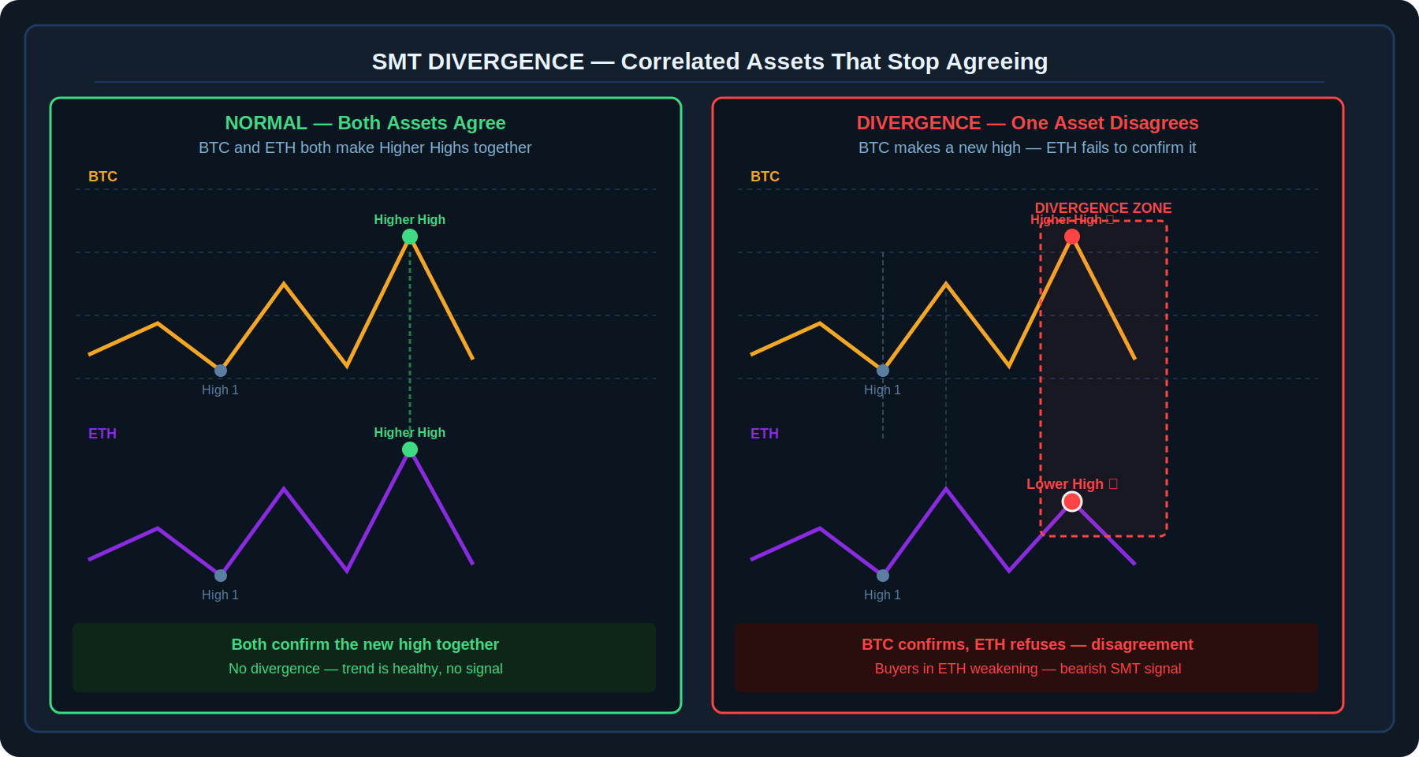
Diagram 1 — Normal correlation (both assets confirm a Higher High together) vs Divergence (one confirms, the other fails)
In normal market conditions, BTC and ETH mirror each other closely on the chart — when BTC makes a Higher High, ETH typically does too, and vice versa for lows. A divergence occurs specifically when this mirroring breaks down at a price extreme:

- One asset reaches a NEW extreme (a fresh Higher High or a fresh Lower Low).
- The correlated asset FAILS to reach that same new extreme — instead forming a Lower High (in an up-move) or a Higher Low (in a down-move).
- This failure to confirm is read as weakening conviction behind the move in the lagging asset — which, given how tightly correlated the two assets normally are, signals the broader move itself may be losing steam.

3. Bearish Divergence — Short Setup
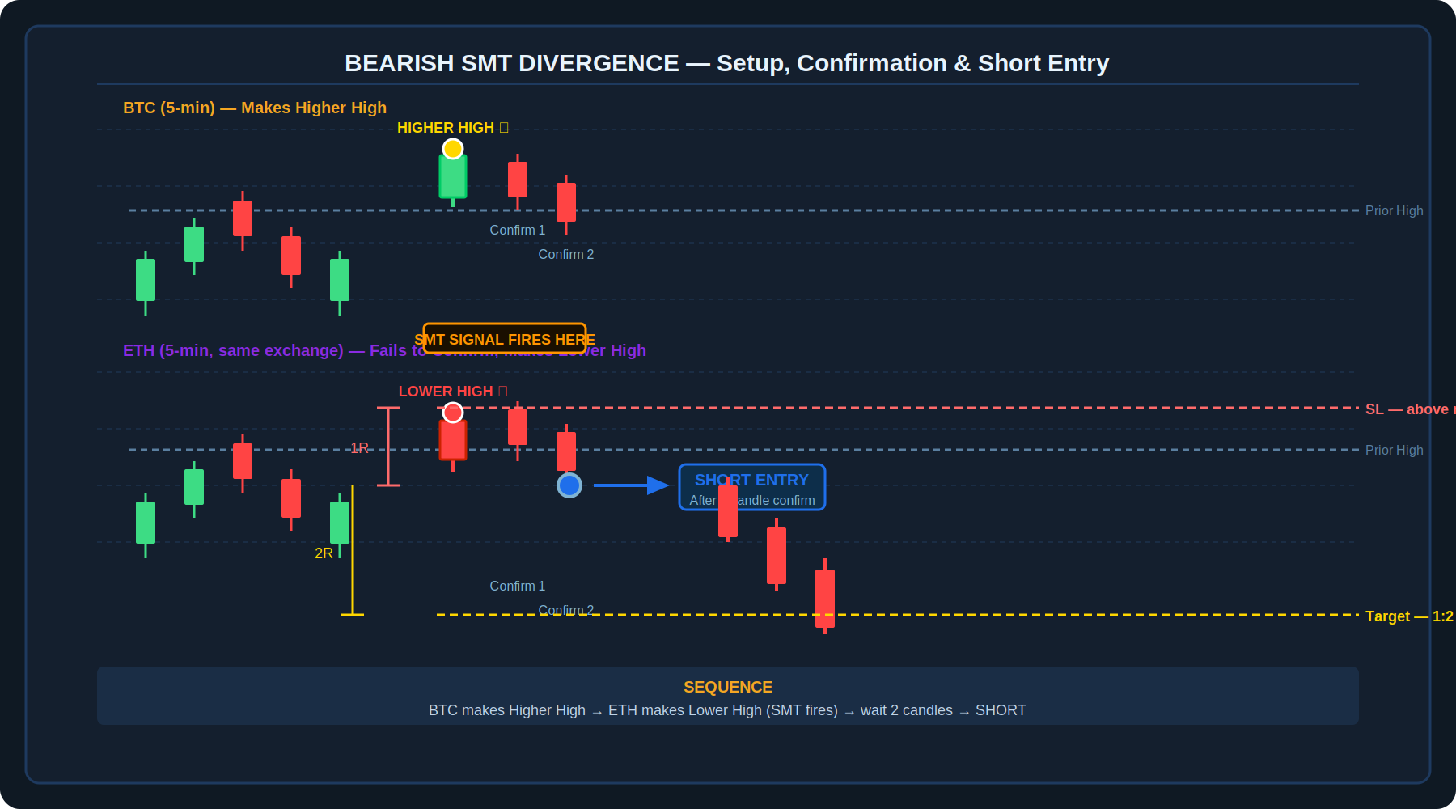
Diagram 2 — Bearish SMT: BTC confirms a Higher High while ETH forms a Lower High, triggering a 2-candle confirmation wait before shorting
Bearish Divergence — Step-by-Step
- Condition: One asset (e.g., BTC) makes a Higher High. The correlated asset (e.g., ETH) fails to break its own previous high and instead forms a Lower High.
- Interpretation: Buyers in the lagging asset (ETH) are becoming weak. Sellers are starting to take control there — and by extension, in the broader correlated move.
- Confirmation: Wait for the SMT signal to appear (manually or via indicator), then wait two additional candles to confirm the signal before entering. This avoids acting on a divergence that resolves itself immediately.
- Entry: Enter a SHORT position once the two-candle confirmation has passed.
- Stop Loss: Place the stop loss slightly above the recent high (the point that would invalidate the bearish divergence if broken).
- Target: Use a 1:2 risk-to-reward ratio, or target the previous swing low as an alternative reference.

4. Bullish Divergence — Long Setup
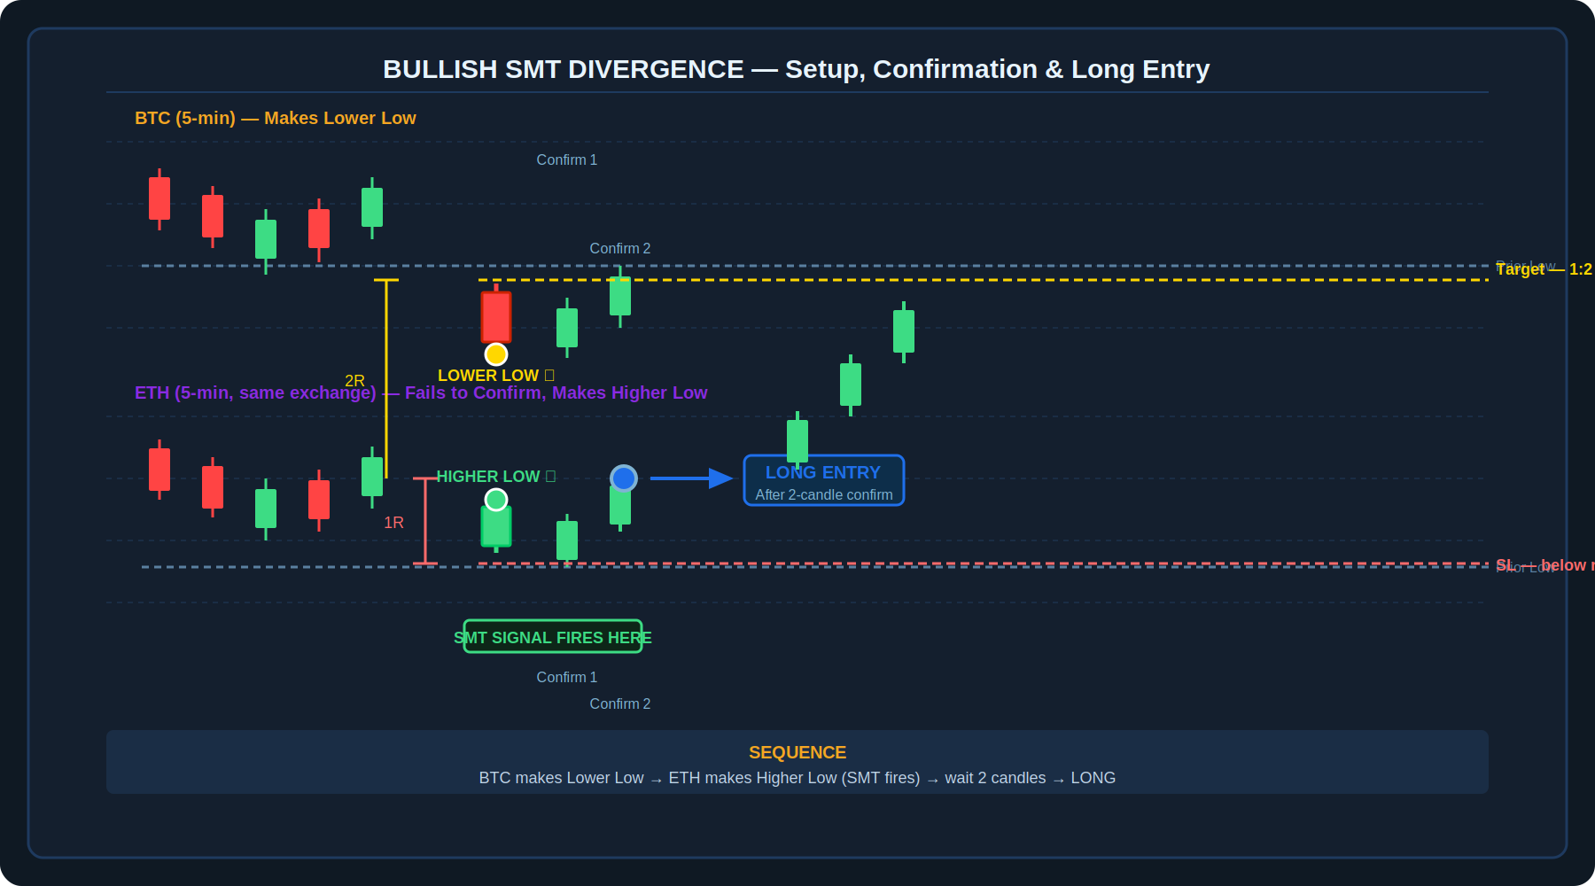
Diagram 3 — Bullish SMT: BTC confirms a Lower Low while ETH forms a Higher Low, triggering a 2-candle confirmation wait before going long
Bullish Divergence — Step-by-Step
- Condition: One asset (e.g., BTC) makes a Lower Low. The correlated asset (e.g., ETH) fails to make a new low and instead forms a Higher Low.
- Interpretation: Selling pressure is exhausting in the lagging asset (ETH). Buyers are beginning to gain strength there — suggesting the broader downward move may be losing momentum.
- Confirmation: As with the bearish setup, wait for the SMT signal to appear, then wait two additional candles before entering.
- Entry: Enter a LONG position once the two-candle confirmation has passed.
- Stop Loss: Place the stop loss below the recent low (the point that would invalidate the bullish divergence if broken).
- Target: Use a 1:2 risk-to-reward ratio for the profit target.

⚠️ | The two-candle confirmation rule exists specifically because the SMT signal — especially when read from an indicator — can occasionally flicker or shift as the most recent candle is still forming. Waiting two full candles after the signal appears filters out a meaningful share of false or premature triggers.

5. Tools and Chart Settings
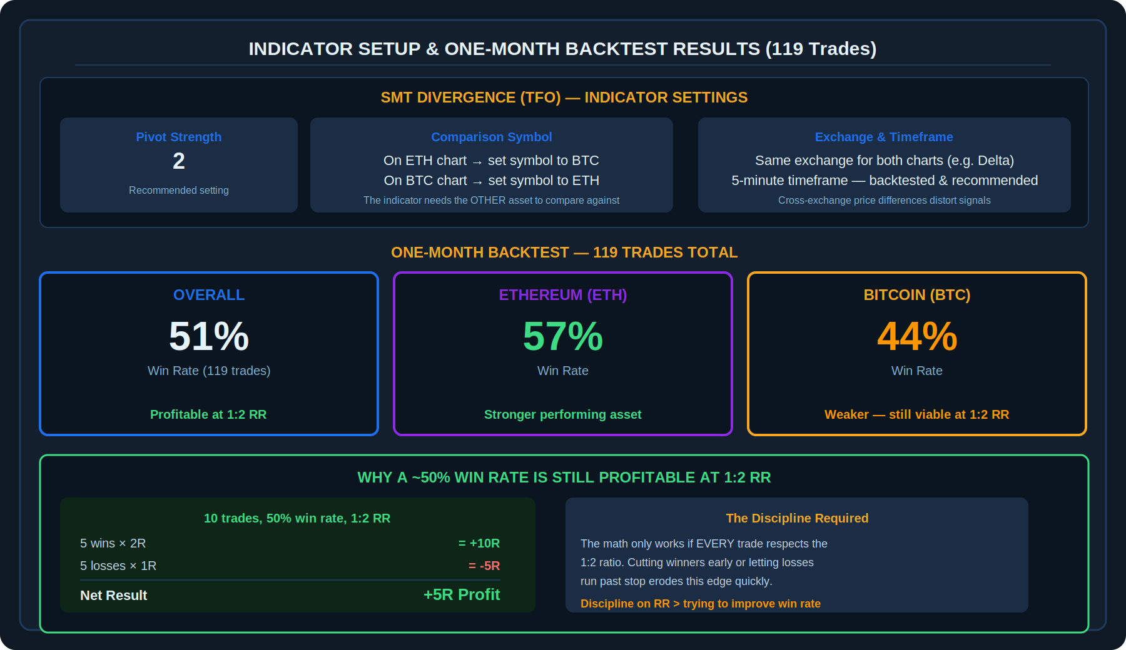
Diagram 4 — SMT Divergence (TFO) indicator settings, plus the full one-month backtest scorecard (119 trades)
While SMT divergence can be identified manually by watching two charts side by side, the strategy is built around the "SMT Divergence (TFO)" indicator on TradingView, which automates detection of the divergence pattern between two specified symbols.

Setting | Specification
Timeframe | 5-minute chart — specifically backtested and recommended for this strategy
Pivot Strength | Set to 2 in the indicator settings
Comparison Symbol | On the ETH chart, set the indicator's comparison symbol to BTC (and vice versa when trading the BTC chart) — the indicator needs the other asset to compare against
Exchange Consistency | Use charts from the SAME exchange (e.g., Delta Exchange) for both assets to ensure accurate comparison — cross-exchange price discrepancies can distort the signal

6. Backtest Results and Risk Management
The strategy was tested over a one-month period, producing the following results across 119 total trades:

Scope | Win Rate | Notes
Overall (119 trades) | ~51% | Profitable when paired with strict 1:2 RR
Ethereum (ETH) trades | 57% | Stronger-performing asset in this backtest
Bitcoin (BTC) trades | 44% | Weaker, but still viable given the 1:2 RR structure

A roughly 50% win rate would be a losing proposition at 1:1 risk-to-reward, but becomes solidly profitable at 1:2 — this is precisely why the risk management rule is treated as essential to the strategy, not optional.

🔑 | At a 50% win rate with a strict 1:2 RR: 10 trades produce 5 wins worth +2R each (+10R total) and 5 losses worth -1R each (-5R total) — a net of +5R. The strategy's profitability comes directly from disciplined risk-reward sizing, not from a high win rate.

6.1 Manual Verification
The SMT indicator can occasionally glitch or produce an unclear signal — particularly around fast-moving or choppy price action. If a signal from the indicator looks ambiguous, it is recommended to manually verify the divergence by directly comparing both charts side by side before committing to the trade.

7. Pre-Trade Checklist

Bearish (Short) Setup
✓ | Checklist Item
☐ | I am on the 5-minute chart for both BTC and ETH, from the same exchange
☐ | The SMT indicator (or manual comparison) shows one asset making a Higher High
☐ | The correlated asset has failed to make a Higher High — it formed a Lower High instead
☐ | I have waited TWO full candles after the SMT signal appeared before considering entry
☐ | If the signal looked unclear on the indicator, I manually verified it by comparing both charts directly
☐ | Stop loss is placed slightly above the recent high
☐ | Target is set at 1:2 risk-to-reward, or alternatively at the previous swing low

Bullish (Long) Setup
✓ | Checklist Item
☐ | I am on the 5-minute chart for both BTC and ETH, from the same exchange
☐ | The SMT indicator (or manual comparison) shows one asset making a Lower Low
☐ | The correlated asset has failed to make a Lower Low — it formed a Higher Low instead
☐ | I have waited TWO full candles after the SMT signal appeared before considering entry
☐ | If the signal looked unclear on the indicator, I manually verified it by comparing both charts directly
☐ | Stop loss is placed below the recent low
☐ | Target is set at 1:2 risk-to-reward

8. Key Terms
Term | Definition
SMT (Smart Money Tool) Divergence | A trading concept where a divergence between two correlated assets — one confirming a new high/low, the other failing to — is treated as a signal of weakening momentum.
Correlated Assets | Two instruments (such as BTC and ETH) that typically move in the same direction due to shared market drivers and investor behaviour.
Bearish Divergence | One asset makes a Higher High while its correlated partner makes a Lower High instead — signalling weakening bullish momentum and a potential short opportunity.
Bullish Divergence | One asset makes a Lower Low while its correlated partner makes a Higher Low instead — signalling weakening bearish momentum and a potential long opportunity.
Higher High (HH) | A swing high that exceeds the previous swing high — confirms continued upward momentum in the asset making it.
Lower High (LH) | A swing high that fails to exceed the previous swing high — signals weakening upward momentum.
Lower Low (LL) | A swing low that falls below the previous swing low — confirms continued downward momentum.
Higher Low (HL) | A swing low that fails to fall below the previous swing low — signals weakening downward momentum.
Two-Candle Confirmation | Waiting for two full candles to close after an SMT signal appears before entering a trade, to filter out premature or false signals.
Pivot Strength | An indicator setting controlling how many candles on each side are required to confirm a swing high or low. Set to 2 for this strategy.
1:2 Risk-to-Reward (RR) | A trade structure where the profit target is twice the distance of the stop loss from entry. Central to this strategy's profitability at a near-50% win rate.
SMT Divergence (TFO) | The specific TradingView indicator used to automate detection of SMT divergence between two specified symbols.

Disclaimer
This document is produced solely for educational and informational purposes. The strategy described herein is presented as a learning framework and does not constitute financial advice, a recommendation to trade, or a guarantee of any specific outcome. Cryptocurrency trading involves substantial risk of loss and is not suitable for all investors. Backtest results cited are historical and illustrative only; past performance is not indicative of future results. Always conduct your own due diligence and consult a qualified financial adviser before engaging in any trading activity.

