THE 8020 STRATEGY
Okala's Nasdaq Mean Reversion System
"The system behind $5 million+ in prop firm payouts"
80/20 Levels | Mean Reversion | Nasdaq NQ | 10-min + 200-second Charts | Mobile Execution
Instrument  Nasdaq (NQ) Futures | Key Levels  Prices ending in 80 and 20 | SL  Static 10 points | TP1  15 points → move to breakeven

1. Overview — Okala and the 8020 Strategy
The 8020 Strategy is a mean reversion trading system developed by a trader known as Okala, who has used it to generate over $5 million in payouts from proprietary trading firms. The strategy is built around a single, repeatable observation: the Nasdaq futures (NQ) consistently reacts to price levels ending in 80 and 20. Rather than following trends, the strategy identifies these key levels, waits for specific market structure patterns to form at them, and enters trades expecting price to revert back toward the mean.

What makes this system particularly notable is its simplicity. Okala designed it to be executed entirely from a mobile phone, with no order flow tools, no complex indicators, and no algorithmic assistance. The edge comes entirely from reading price structure and recognising repeatable patterns at specific price levels — skills that any committed trader can develop.

💡 | Okala's results — over $5 million in prop firm payouts — came from a system with no complex indicators. The lesson is not that complexity leads to profitability. The lesson is that mastery of a simple, well-defined system, applied with strict discipline, is the actual edge.

2. The 80 and 20 Levels — The Foundation
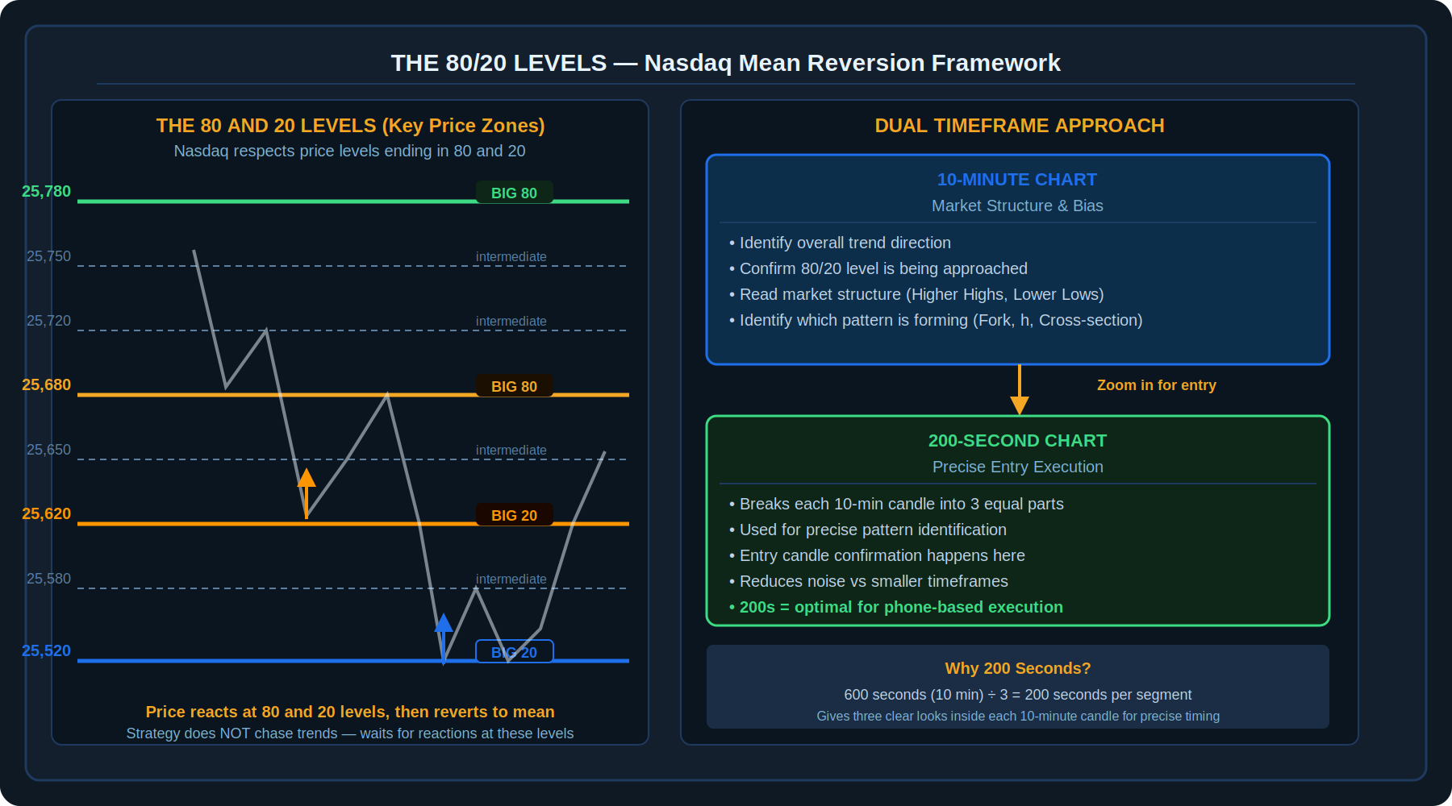
Diagram 1 — The 80/20 level ladder on Nasdaq and the dual timeframe approach (10-min structure + 200-second entry)

2.1 Why 80 and 20?
The strategy's name comes directly from its core observation: the Nasdaq futures market reliably respects price levels that end in 80 and 20. For example, at a price of 25,680 and 25,620, traders and algorithms consistently place orders, creating areas where price reacts, reverses, or at minimum shows a measurable hesitation.

While there are intermediate levels (at 50, for instance), the 80 and 20 levels are considered the "big ones" — the primary zones where the highest-probability mean reversion setups occur. When an 80 or 20 level aligns with one of the four entry patterns, it creates a confluence that significantly increases the probability of a reaction.

2.2 Mean Reversion — Not a Trend-Following System
The 8020 Strategy does not chase price. It does not look for momentum entries or breakouts in the traditional sense. Instead, it waits for price to arrive at a key 80 or 20 level and looks for evidence that price is about to reverse and return toward the middle of its recent range. This is mean reversion at its most precise — identifying where price has moved too far too fast and expecting a snap-back.

📌 | Mean reversion logic: markets spend most of their time oscillating between levels rather than trending persistently. The 80/20 levels are the oscillation boundaries. The strategy extracts profit from the movement between these levels rather than trying to predict which direction the market will ultimately go.

2.3 The Dual Timeframe Approach
Timeframe | Purpose | What to Look For
10-Minute Chart | Overall market structure and bias | Trend direction, 80/20 level being approached, which pattern (Fork, h, Cross-section) is forming
200-Second Chart | Precise entry execution | Initiation candle, entry candle confirmation, exact pattern structure detail

The 200-second chart is used because it breaks each 10-minute candle into exactly three equal segments (600 seconds ÷ 3 = 200 seconds). This gives three distinct views of what is happening inside each 10-minute candle — enough detail for precise entry timing without the excessive noise of a 1-minute or 2-minute chart.

3. The Four Entry Patterns
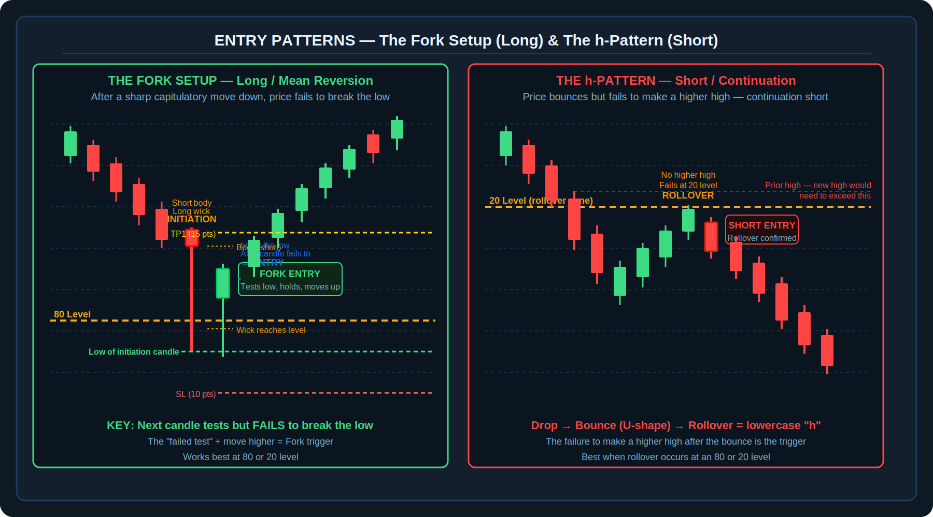
Diagram 2 — Fork Setup (left): capitulatory candle + failed test of the low → long. h-Pattern (right): sharp drop + failed bounce at level → short

3.1 The Fork Setup — Long / Mean Reversion
The Fork setup is a long (buy) entry used after a sharp, aggressive move downward. It is named for the visual shape that appears when the initiation candle's range is combined with the following entry candle — the structure resembles a fork. This is a pure mean reversion play: price has moved sharply lower, touched or approached an 80 or 20 level, and is expected to snap back.

Fork Setup — Identification and Entry
- Step 1: Identify a sharp, capitulatory move downward on the 200-second chart — price falling quickly with aggression.
- Step 2: Look for an initiation candle — a candle with a long wick pointing toward the 80 or 20 level and a very short body. This signals exhaustion of selling pressure.
- Step 3: The next candle is the entry candle. Watch for this candle to dip down to test the low of the initiation candle but FAIL to break below it.
- Step 4: Once the candle fails to break the low and begins to move higher, enter the long trade at that point.
- Step 5: Stop loss is set 10 points below the entry. Targets are TP1 at 15 points and TP2 at 30 points, with a runner for 60+ points if momentum is strong.
- Best condition: The initiation candle low is at or very near an 80 or 20 price level — this confluence significantly raises probability.

📌 | The "failed test" of the low is the critical signal in the Fork setup. The entry candle must touch or come very close to the prior low — if it immediately moves away without testing, the setup is not valid. The test-and-fail is the evidence that buyers have taken control.

3.2 The h-Pattern — Short / Continuation
The h-Pattern is Okala's preferred short entry setup. It is named for the visual resemblance to a lowercase letter "h": price drops sharply (the downstroke), bounces briefly (the curved portion of the h), and then fails to make a higher high before rolling back down (the descending right portion). It is a short-side continuation trade, not a reversal.

h-Pattern — Identification and Entry
- Step 1: Identify a sharp price drop on the 200-second chart — the initial downstroke of the h.
- Step 2: Price bounces and forms a U-shaped recovery — the curved bottom portion of the h.
- Step 3: The bounce must FAIL to make a higher high than the swing high before the initial drop. This failed recovery is the key condition.
- Step 4: The rollover — price begins turning back down from the failed high — is the entry trigger. Best when this rollover occurs at an 80 or 20 level.
- Step 5: Enter short at the rollover. Stop loss 10 points above entry. TP1 at 15 points, TP2 at 30 points, runner for 60+ points.
- Confirmation: The rollover at an 80 or 20 level combined with the h-structure creates a high-confluence short entry.

4. Cross-Section Entry and Repair Candles
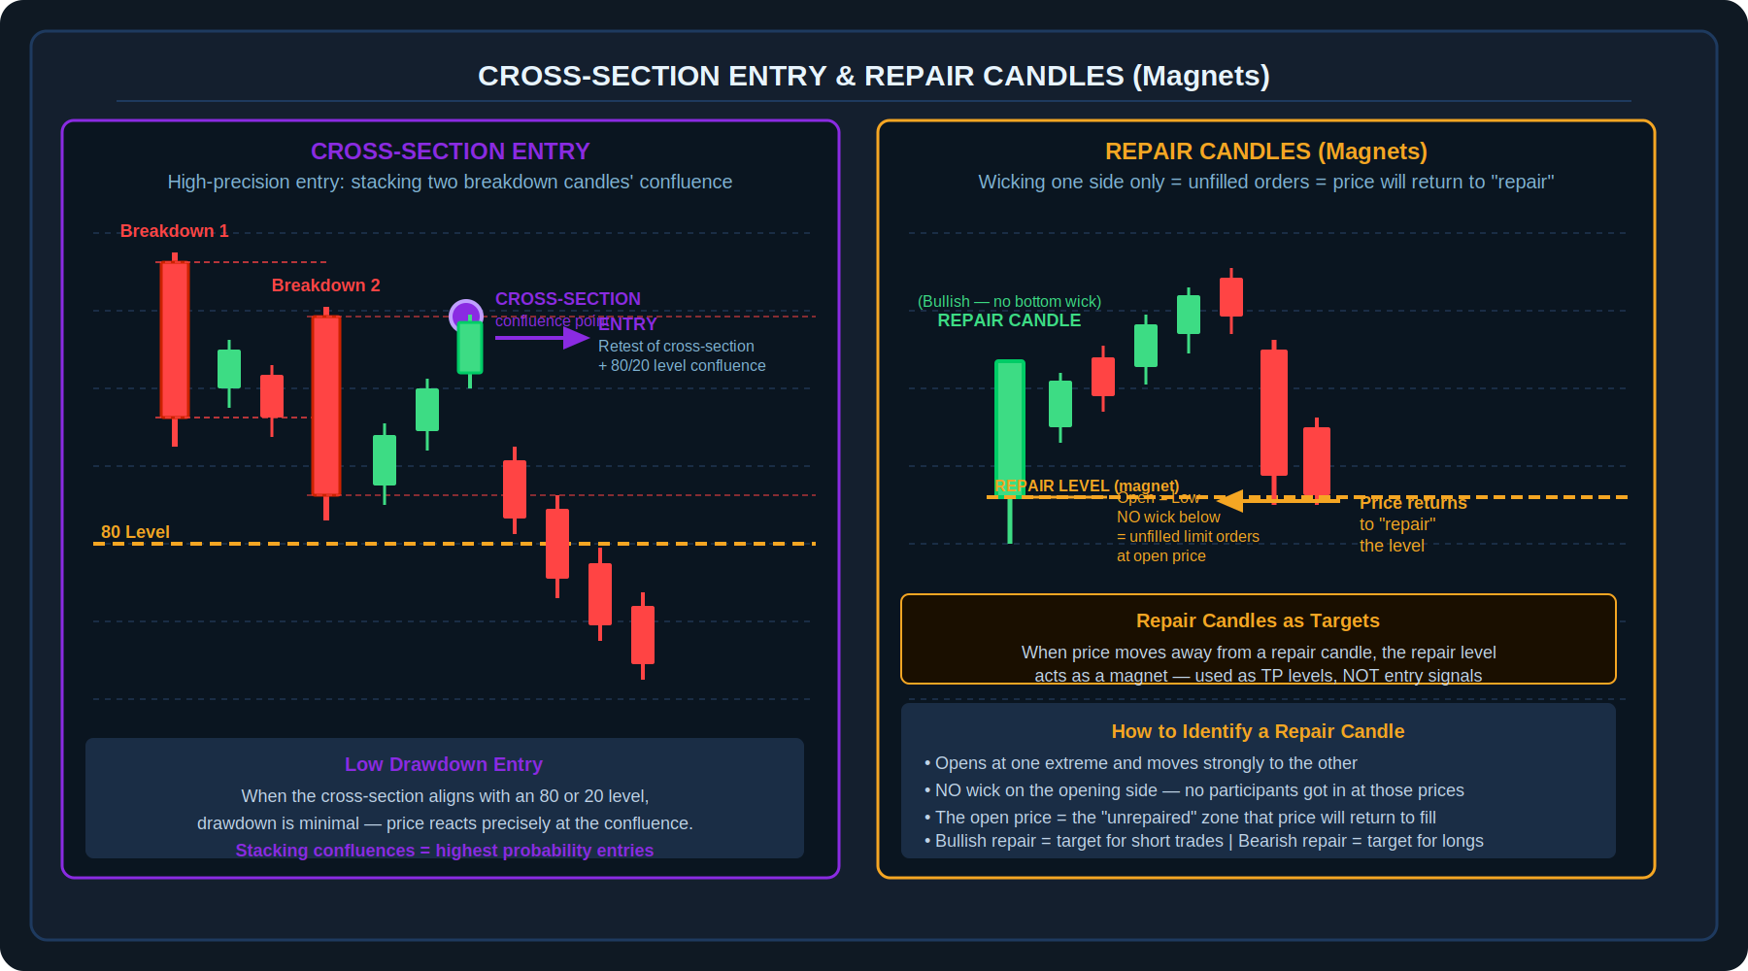
Diagram 3 — Cross-Section Entry (left): overlap of two breakdown candles creates a precision confluence. Repair Candles (right): wicking one side only = unfilled orders = magnetic target

4.1 The Cross-Section Entry — Stacking Confluences
The cross-section model is the highest-precision entry in the 8020 system. It is used when two breakdown candles overlap and create a specific meeting point — a "cross-section" — that acts as a precise price level where a retest is expected. When this cross-section level also coincides with an 80 or 20 level, the confluence is exceptionally strong.

The logic is structural: when two significant bearish candles break down through a zone, their combined structural overlap creates a specific price point that the market treats as meaningful. Entries at this exact point tend to result in minimal drawdown because price reacts very precisely at the confluence.

Cross-Section Entry — How to Identify and Trade It
- Identify two breakdown candles — two significant bearish moves through a price zone on the 200-second chart.
- Mark the open, high, low, and close of both candles. Identify where their ranges overlap or "cross-section."
- The cross-section point is where the structure of one candle intersects with the structure of the other.
- Wait for price to pull back to this exact cross-section level. When it retests there, look for a rejection candle.
- If the cross-section aligns with an 80 or 20 level, this is a maximum-confluence setup. Enter on the rejection. Stop loss 10 points beyond the entry.
- This entry is distinguished by very low initial drawdown — price reacts extremely precisely at the confluence point.

4.2 Repair Candles — Price Magnets
A repair candle is a candle that opens at one extreme of its range and moves powerfully in one direction — with no wick on the starting side. This means no other participant had the opportunity to enter at the open price. The absence of a wick indicates that limit orders at that level went unfilled.

Because these orders remain unfilled, price is drawn back to "repair" them — to return and fill those limit orders. This creates a magnetic effect: repair candle levels consistently act as price magnets, pulling the market back to revisit the open price of the repair candle.

Repair Candles — How to Use Them
- Identify a candle that opens at one extreme and moves powerfully in one direction — the opening side has no wick at all.
- A bullish repair candle (opens at the low, moves up with no bottom wick) will attract price downward to repair it — use as a target for short trades.
- A bearish repair candle (opens at the high, moves down with no top wick) will attract price upward to repair it — use as a target for long trades.
- Repair candles are primarily used as TARGETS, not as entry triggers. When a trade is already open, identify nearby repair candles as the likely stopping point for the move.
- Do not enter a trade just because a repair candle exists — wait for one of the four entry patterns at an 80 or 20 level first.

🔑 | Repair candles are powerful as targets because they represent a genuine market imbalance — unfilled orders that the market is compelled to return and fill. Unlike arbitrary take-profit levels, a repair candle target has a structural reason behind it.

5. Trade and Risk Management
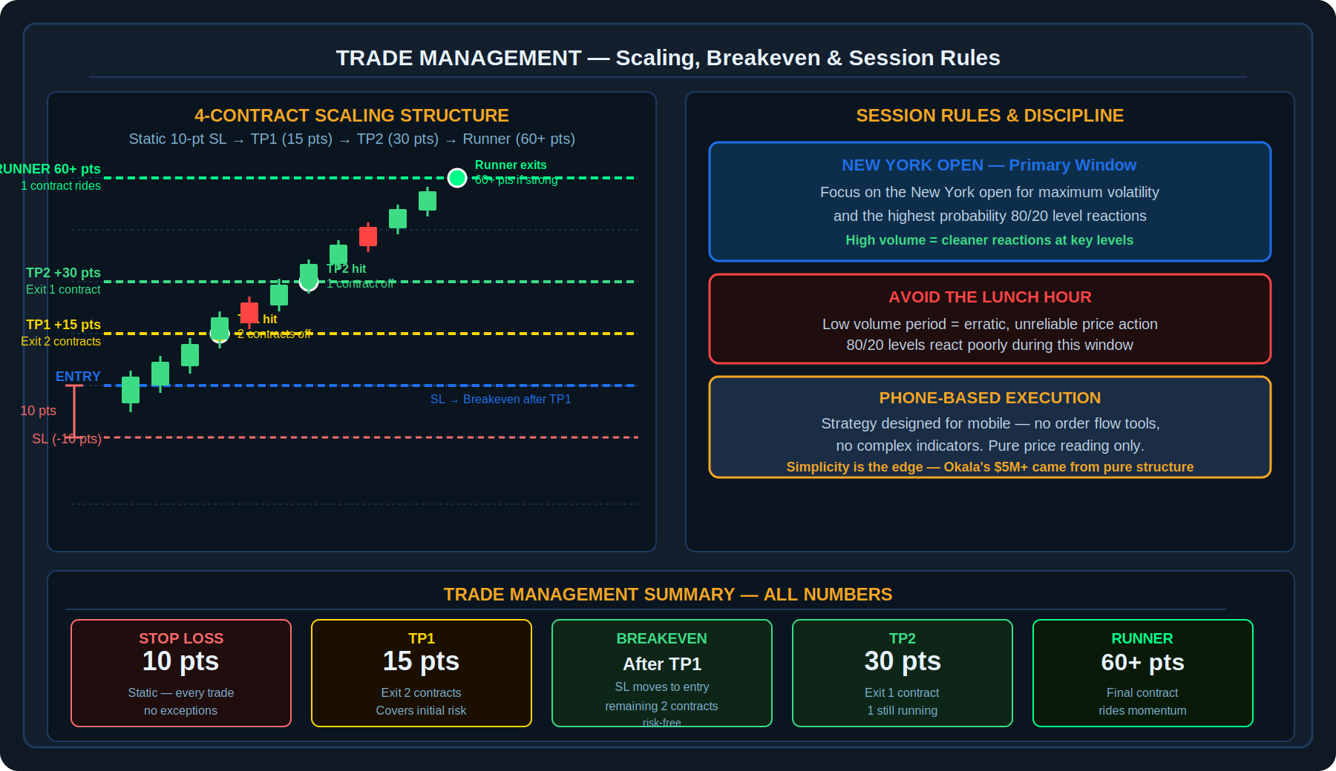
Diagram 4 — 4-contract scaling structure: TP1 at 15 pts (2 contracts), TP2 at 30 pts (1 contract), Runner at 60+ pts (1 contract). Session rules: NY Open only, avoid lunch.

5.1 The Static Stop Loss — 10 Points
Every trade in the 8020 Strategy uses the same static stop loss: 10 points. This is non-negotiable and applies to every entry regardless of market conditions, volatility, or confidence level. The static stop loss serves two purposes: it creates consistent risk quantification across all trades, and it forces the trader to only take setups where a 10-point stop is structurally rational given the pattern.

⚠️ | A 10-point static stop loss means that before entering any trade, the trader must confirm that a 10-point stop is appropriately placed relative to the pattern. If the correct structural stop would need to be wider than 10 points, the setup is skipped — the entry is subpar.

5.2 The Scaling Structure — 4 Contracts
Okala trades the 8020 system with multiple contracts, scaling out as the trade progresses. The full scaling structure with 4 contracts is as follows:

Level | Points | Contracts Exited | Action
TP1 | + 15 pts | 2 of 4 (50%) | Exit half the position. Move stop loss to break even on remaining 2 contracts.
TP2 | + 30 pts | 1 of 4 (25%) | Exit one more. 1 contract remains with no risk (stop at break even).
Runner | 60+ pts | 1 of 4 (final) | Allow the final contract to run as long as momentum continues. Exit when structure breaks.

The TP1 target of 15 points is specifically designed to cover the initial 10-point risk. By exiting 2 contracts at 15 points (2 × 15 = 30 points of gross profit) against 4 contracts at 10 points of risk (40 points total risk), TP1 does not fully cover the total initial risk — but it does significantly reduce it. Once TP1 is hit and the stop moves to break even, the remaining 2 contracts are risk-free.

5.3 The Breakeven Rule
As soon as TP1 is hit, the stop loss on the remaining 2 contracts is immediately moved to break even — to the original entry price, or slightly beyond to cover commissions. This rule is absolute. The purpose is to eliminate the possibility of a TP1-hitting trade ultimately being a losing trade. Once TP1 is reached, the worst outcome is break even.

5.4 Session Rules
Session Timing Rules
- Primary Session: Focus on the New York open. This is when volatility is highest and the 80/20 levels produce their strongest, most reliable reactions. Volume at the open ensures that price reacts decisively when it hits key levels.
- Avoid the Lunch Hour: The midday period (approximately 12:00–13:30 NY time) is characterised by low volume and erratic, unreliable price action. The 80/20 levels do not react cleanly during this window. Skip it entirely.
- The 8020 Strategy can provide multiple valid setups per day during the primary window. The discipline challenge is not finding entries — it is avoiding subpar entries that do not meet all criteria.

6. Discipline and Execution
Okala is explicit about a key challenge: the strategy can generate many signals per session, and the temptation to take lower-quality setups is significant. The entire edge of the system depends on taking only entries where all conditions are met — the right pattern, at the right level, with the right candle structure.

- Avoid subpar entries: If the pattern is not perfectly clear, or the 80/20 level is not precisely at the interaction point, skip the trade. The next setup is not far away.
- No indicators needed: The 8020 system is designed for pure price reading. Adding indicators often introduces conflicting signals and reduces clarity. The structure itself is the signal.
- Mobile-first design: The strategy was specifically developed to work on a phone. This constraint is a feature — it forces simplicity and eliminates the temptation to over-analyze with complex tools.
- Prop firm consistency: The static 10-point stop loss and the breakeven rule after TP1 are specifically calibrated for the consistency requirements of proprietary trading firms. Capital preservation during losing streaks is what keeps the account alive for the winning trades.

🧠 | The most common mistake in the 8020 Strategy is forcing entries at levels that are "close to" 80 or 20 but not precisely there, or taking a trade where the pattern is only partially formed. Okala's $5 million came from the trades that met all criteria — not from forcing trades that almost met them.

7. Pre-Trade Checklist
✓ | Checklist Item
☐ | I am in the New York open session — not the lunch hour
☐ | I have identified an 80 or 20 level (price ending in 80 or 20) that price is approaching or has reached
☐ | I am on the 10-minute chart to confirm overall market structure and identify which pattern is forming
☐ | I have switched to the 200-second chart for entry precision
☐ | ONE of the four patterns is clearly present: Fork Setup, h-Pattern, Cross-Section, or a setup with a Repair Candle target
☐ | For the Fork Setup: A capitulatory initiation candle with long wick and short body has formed. The next candle has tested the low but failed to break it.
☐ | For the h-Pattern: A sharp drop followed by a bounce that failed to make a higher high. Rollover is occurring at or near an 80 or 20 level.
☐ | For the Cross-Section: Two breakdown candles have been identified. The cross-section level has been marked. Price is retesting this level, ideally at an 80 or 20 confluence.
☐ | My stop loss is set at exactly 10 points from entry — the structural stop makes sense at this distance
☐ | TP1 is set at 15 points. If using 4 contracts, 2 will be exited here.
☐ | TP2 is set at 30 points. 1 contract will be exited here.
☐ | After TP1 is hit, the stop loss will be moved to break even immediately — no exceptions.
☐ | I have identified any nearby repair candles that may act as targets or magnets for the move
☐ | I am not forcing this entry — all conditions are genuinely met, not just approximately met

8. Key Terms
Term | Definition
80/20 Levels | Price levels on the Nasdaq where the final two digits end in 80 or 20 (e.g., 25,680 or 25,620). The primary zones where the 8020 Strategy expects price reactions and entries.
Mean Reversion | The principle that after a sharp move away from the centre of a range, price will tend to return toward the mean. The 8020 Strategy is a mean reversion system — it trades the snap-back, not the initial move.
10-Minute Chart | The primary timeframe for reading overall market structure and identifying which 80/20 level is being approached and which pattern is forming.
200-Second Chart | The entry execution timeframe. Breaks each 10-minute candle into three equal segments for precise pattern identification and entry timing.
Fork Setup | A long (buy) entry triggered after a sharp capitulatory drop. The initiation candle has a long wick and short body; the next candle tests the low but fails to break it — triggering the long entry.
Initiation Candle | The candle in the Fork Setup with a long wick reaching toward the 80/20 level and a short body. Signals exhaustion of the selling move.
h-Pattern | A short (sell) entry pattern resembling a lowercase "h." Price drops sharply, bounces, but fails to make a higher high before rolling back down. The rollover at an 80/20 level triggers the short entry.
Rollover | In the h-Pattern, the moment price turns back down from its failed bounce high. This is the entry trigger for the short trade.
Cross-Section | The specific price level where two breakdown candles' ranges overlap, creating a high-precision confluence point. Often combined with an 80/20 level for maximum probability.
Repair Candle | A candle that opens at one extreme and moves powerfully in one direction with no wick on the starting side. Indicates unfilled limit orders at the open price, creating a magnetic target level.
Unfilled Limit Orders | Orders placed at a price that was never reached during a repair candle's formation. These orders remain in the market and draw price back to fill them — the mechanism behind repair candle magnetism.
Static Stop Loss | A stop loss of exactly 10 points applied to every trade in the 8020 Strategy, regardless of conditions. Enforces consistent risk quantification.
TP1 | First take-profit target at 15 points. Used to exit 2 of 4 contracts and cover the majority of initial risk. Triggers the breakeven rule.
Breakeven Rule | After TP1 is hit, the stop loss on remaining contracts is moved to the entry price (or slightly beyond for commissions). Eliminates the possibility of a TP1-hitting trade becoming a net loss.
Runner | The final contract in the scaling structure, allowed to run for 60+ points if momentum remains strong. Provides the outsized gains that make the system highly profitable over time.
Subpar Entry | A trade setup that partially — but not fully — meets all criteria. Okala specifically warns against taking subpar entries, which are the primary cause of unnecessary losses in the system.

Disclaimer
This document is produced solely for educational and informational purposes. The 8020 Strategy is attributed to a trader known as Okala and is presented here based on publicly available descriptions of the strategy for educational purposes. This document is not affiliated with or endorsed by Okala. The trading results cited ($5 million+ in prop firm payouts) are attributable to a specific individual's application of this system and are not representative of typical results. Trading in financial markets involves substantial risk of loss. Nothing in this document constitutes financial advice or a recommendation to trade. Always conduct your own due diligence and consult a qualified financial adviser before committing real capital.

