4-HOUR SMA CROSSOVER STRATEGY
20 SMA · 200 SMA · Retrace Entry · 25-Pip Trailing Stop (2026 Update)
A Complete Trader's Reference Guide — EUR/USD · EUR/AUD · EUR/NZD · Gold
Timeframe  4-Hour Chart | Entry Trigger  Retrace within 5 pips of 20 SMA | SL / TP1  50 pips / 40 pips | Trail (2026)  25-pip trailing stop after TP1

1. Strategy Philosophy — Why the 4-Hour Chart?
The 4-hour chart sits in a productive middle ground that most traders overlook. The 1-minute and 5-minute charts produce a constant stream of signals that are largely market noise — small, random price fluctuations that generate trades but not meaningful directional moves. Traders on these timeframes face burnout, wide spreads relative to profit targets, and a relentless need to be in front of screens.

Daily and weekly charts solve the noise problem but introduce new ones: setups appear rarely, stop losses are wide (often hundreds of pips), and trades can sit open for weeks. The 4-hour chart threads this needle — it filters out intraday noise, generates clean and readable signals, produces manageable stop loss distances, and still delivers substantial pip moves that justify the trades.

💡 | This strategy is built for patient, selective traders. Expect approximately one high-quality setup per week. Some weeks will produce zero qualifying setups. That is correct behaviour — not a problem. Forcing trades when the setup does not exist is the fastest way to lose on a strategy designed around quality over quantity.

2. Indicator Setup — The 20 SMA and 200 SMA
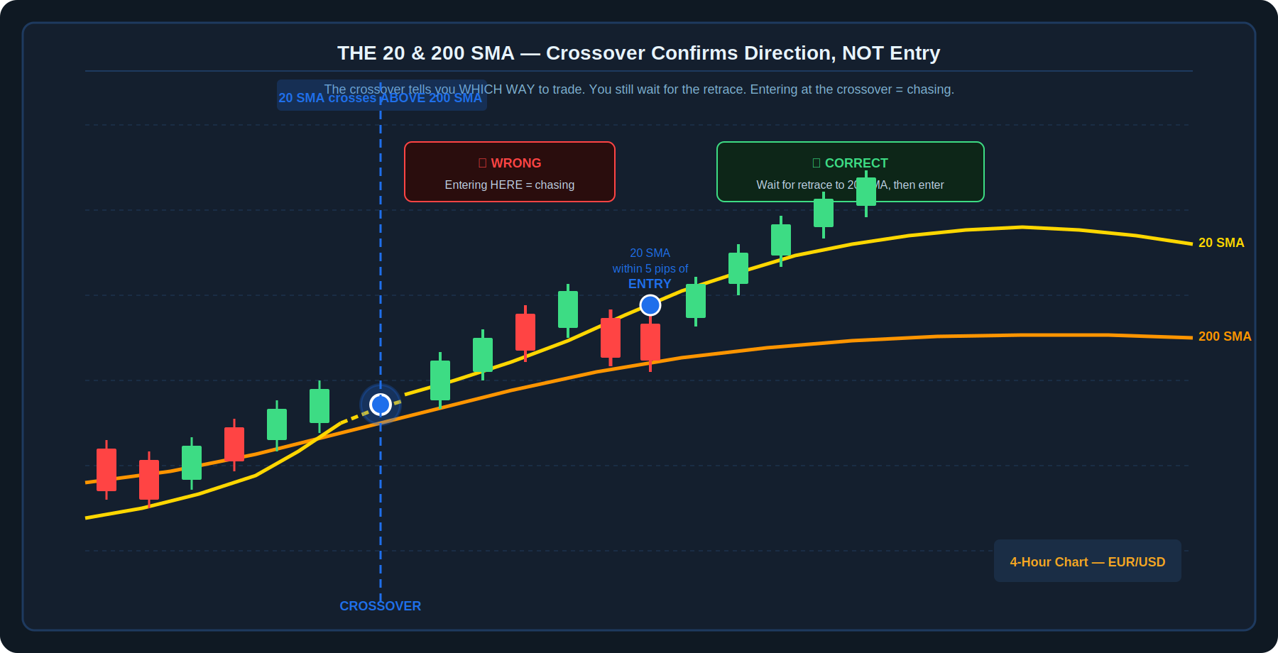
Diagram 1 — The 20 SMA (yellow, fast) crossing above the 200 SMA (orange, slow) on a 4-hour chart. The crossover confirms the directional bias. The actual entry is NOT at the crossover — it is at the subsequent retrace to within 5 pips of the 20 SMA.

Why 20 and 200 — Not 5 and 50?
The 5 SMA and 50 SMA are traditional settings used across many platforms. In practice, they generate frequent crossovers during sideways, consolidating market conditions — most of which produce false signals or quickly reverse. The higher settings (20 and 200) smooth out this noise significantly. The 20 SMA provides a responsive but not jittery read on short-term momentum. The 200 SMA is the widely-watched institutional long-term trend indicator.

The result: fewer signals, each carrying more statistical weight. A crossover of the 20 SMA above the 200 SMA on a 4-hour chart represents a meaningful shift in momentum — not just a brief fluctuation.

The Two SMA Rules
- 20 SMA crosses ABOVE the 200 SMA: directional bias switches to bullish. Look for LONG setups only. Do not take short trades.
- 20 SMA crosses BELOW the 200 SMA: directional bias switches to bearish. Look for SHORT setups only. Do not take long trades.
- The crossover is a BIAS CONFIRMATION, not an entry signal. Entering immediately at the crossover means buying at the top of the move that caused the cross — poor risk-to-reward.
- Once the bias is set, wait patiently. The setup begins only when price retraces back toward the 20 SMA.

3. The Retrace Entry — Where to Actually Get In
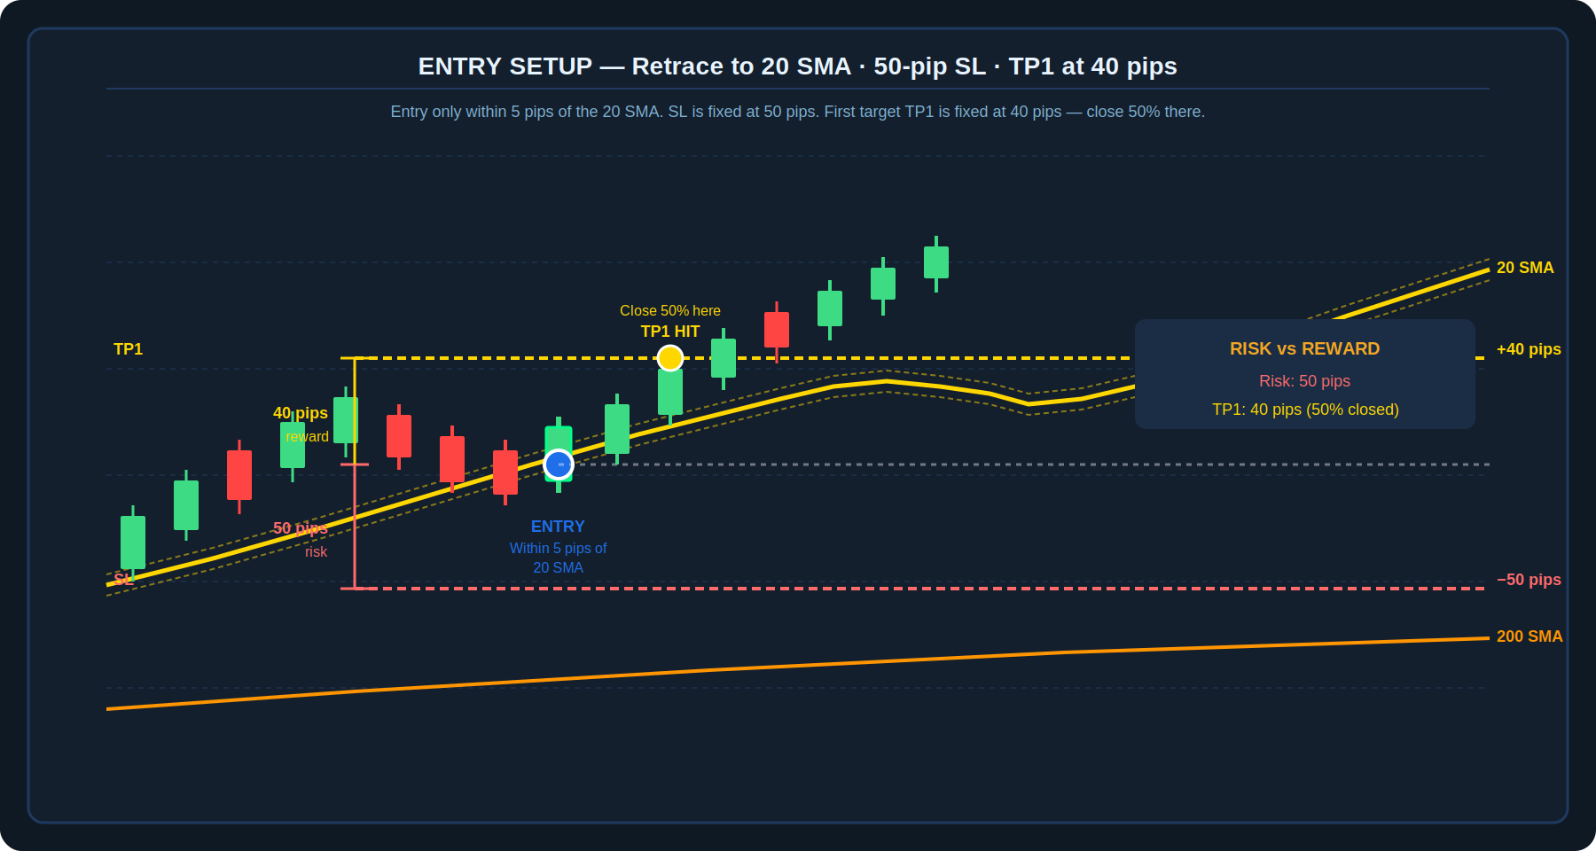
Diagram 2 — After the bullish crossover, price pulls back to within 5 pips of the 20 SMA. Entry is taken here. Stop loss is fixed at 50 pips below entry. TP1 is fixed at 40 pips above entry — close 50% of the position at TP1.

Why Wait for the Retrace?
Entering at the crossover means buying after price has already moved significantly in one direction. The crossover itself is often a momentum peak — the first bar after the cross may already be overextended relative to the 200 SMA. The retrace to the 20 SMA achieves two things: it improves the entry price significantly, and it confirms that the 20 SMA is acting as dynamic support (in an uptrend) — meaning the level has been tested and has held.

The 5-pip tolerance window around the 20 SMA acknowledges that on a 4-hour chart, price rarely lands exactly on a moving average. A small buffer allows practical entry without requiring pixel-perfect execution.

Fixed Trade Parameters
This strategy uses fixed pip-based parameters rather than ATR-based or percentage-based sizing. This makes execution straightforward and consistent across different setups.

Entry Rule | Price retraces to within 5 pips of the 20 SMA after a confirmed crossover

Stop Loss | 50 pips below entry (long) / 50 pips above entry (short)

TP1 — First Target | 40 pips in the direction of the trade — close 50% of position here

⚠️ | TP1 is set at 40 pips — slightly less than the 50-pip risk. This means TP1 alone does not achieve 1:1 RR. The strategy's positive expectancy depends on the second half of the position being managed correctly with the trailing stop, which captures the larger moves. Do not exit the full position at TP1.

4. The 2026 Trade Management Update — The 25-Pip Trail
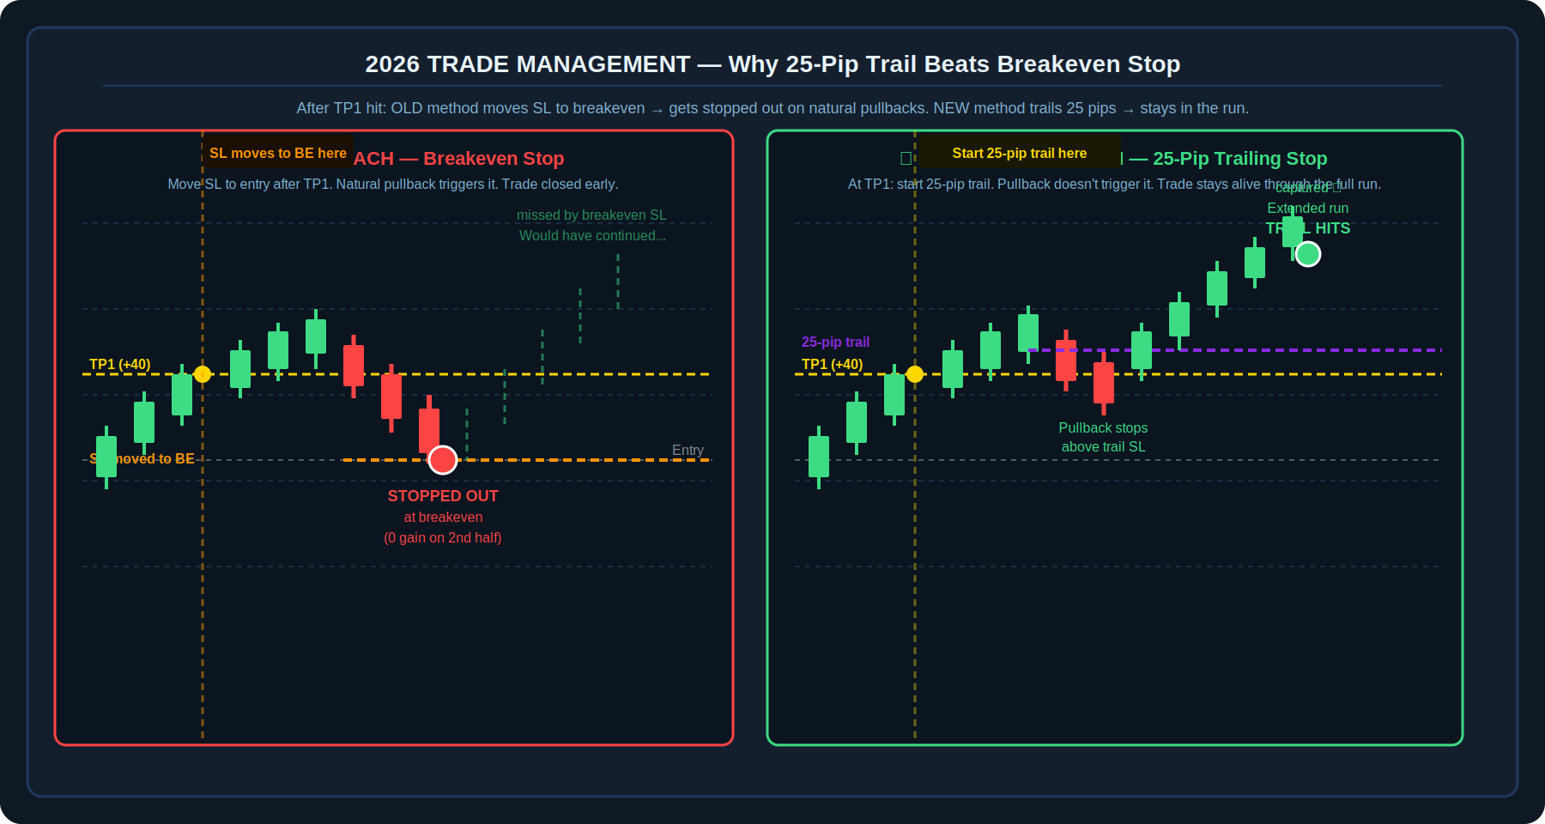
Diagram 3 — Left panel (old approach): SL moves to breakeven at TP1. A natural pullback triggers the breakeven stop, closing the trade for zero gain on the second half — missing the extended run. Right panel (2026 approach): a 25-pip trailing stop starts at TP1. The pullback does not reach it. Trade stays open and captures the full trend run.

The Problem with Breakeven Stops
The intuitive approach after hitting TP1 is to move the stop loss to the entry price (breakeven), guaranteeing no loss on the trade. The problem is mechanical: trending markets do not move in a straight line. After a 40-pip gain, it is normal for price to pull back 15–25 pips before continuing the trend. A breakeven stop placed at 0 pips from entry will be hit by this normal, healthy pullback — and the trade is closed for no gain on the second half, right before the larger move continues.

This is not a losing trade — but it is a missed opportunity trade, and over many repetitions it dramatically reduces the strategy's overall profitability. The 2026 update addresses this directly.

The 2026 Update — 25-Pip Trailing Stop
How the Trail Works
- At the exact moment TP1 (+40 pips) is reached and 50% of the position is closed, immediately apply a 25-pip trailing stop to the remaining 50%.
- The trailing stop follows price as it continues in the trend direction — it never moves backward against the trade.
- If price pulls back by 25 pips from its most recent high (for longs), the trail triggers and the remaining position is closed.
- If price continues trending without a 25-pip pullback, the trail continues advancing, capturing an extended run potentially worth 80, 100, 150 pips or more.
- Practical implementation: most platforms (MT5, cTrader) support native trailing stops. Set the trail at 25 pips immediately after TP1 fills.

Old Approach (Breakeven Stop) | New 2026 Approach (25-Pip Trail)
Move SL to entry (breakeven) at TP1 | Start 25-pip trailing stop at TP1
Natural 20-pip pullback = stopped out at breakeven | Natural 20-pip pullback = trail holds, trade stays open
Second half profit: 0 pips | Second half profit: potentially 50–150+ pips
Result: missed the extended run repeatedly | Result: captures full trend moves when they occur

5. Worked Example — EUR/AUD Long Trade
The following is a hypothetical trade example illustrating every parameter in sequence. Use this as a reference while reviewing live charts.

Step-by-Step EUR/AUD Long Trade
- Step 1 — Crossover confirmed: On the 4-hour EUR/AUD chart, the 20 SMA crosses above the 200 SMA. Directional bias: LONG only. No entry yet — waiting for the retrace.
- Step 2 — Retrace to 20 SMA: Over the next 2–3 candles, EUR/AUD pulls back. Price touches 1.6285 — within 5 pips of the 20 SMA currently at 1.6282. Entry criteria met.
- Step 3 — Enter long at 1.6285: Stop loss placed at 1.6235 (50 pips below entry). TP1 placed at 1.6325 (40 pips above entry). Position size calculated so 50 pips = maximum 1–2% account risk.
- Step 4 — TP1 hit at 1.6325: EUR/AUD rises to 1.6325. Close 50% of position here — locking in profit. Immediately apply a 25-pip trailing stop to the remaining 50%.
- Step 5 — Trail active: EUR/AUD continues higher to 1.6380. The trailing stop has advanced to 1.6355 (25 pips below the 1.6380 high). Price then pulls back to 1.6358 — trail not triggered. Price resumes to 1.6410.
- Step 6 — Trail triggers at 1.6385: EUR/AUD peaks at 1.6410 and reverses. Trailing stop at 1.6385 (25 pips below peak) triggers. Remaining 50% closed at 1.6385. Total on second half: +100 pips.
- Total result: 50% at +40 pips + 50% at +100 pips = blended gain of +70 pips average on the full position, with a maximum risk of 50 pips.

6. Best Markets and Asset Selection
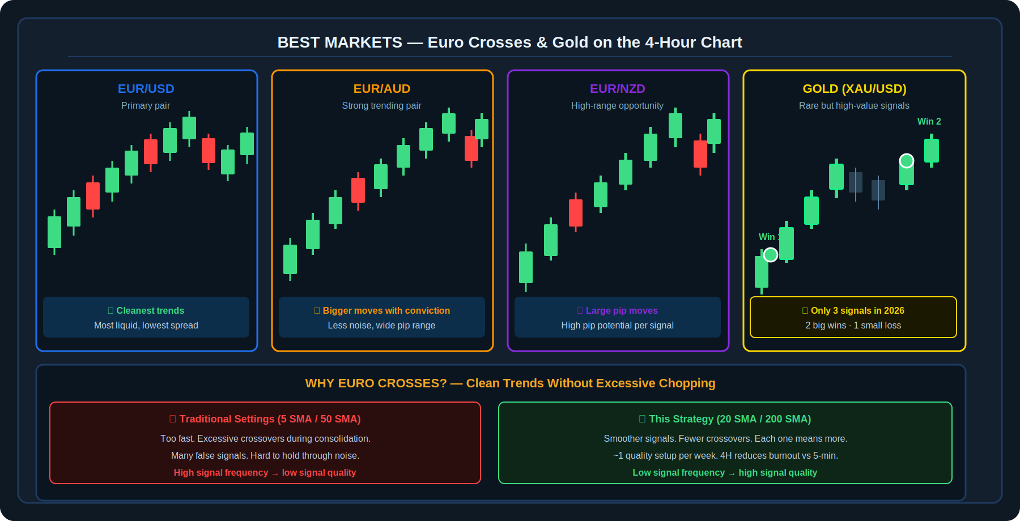
Diagram 4 — EUR/USD (cleanest trends, most liquid), EUR/AUD (bigger conviction moves), EUR/NZD (high pip potential), Gold (rare but high-value signals — only 3 in 2026). Comparison shows why 20/200 SMA beats 5/50 SMA on these instruments.
Instrument | Type | Characteristic | Strategy Fit
EUR/USD | Major Forex Pair | Cleanest, most liquid trends. Lowest spread. Most consistent signals. | Ideal primary pair — start here
EUR/AUD | Cross Pair | Bigger conviction moves, less intraday chop. Strong trends when they develop. | Excellent secondary pair
EUR/NZD | Cross Pair | High pip range per move. Larger position moves in pips. Less liquid than EUR/USD. | Good for experienced traders
Gold (XAU/USD) | Commodity | Rare signals (3 in 2026). Very high pip moves when signals appear. High volatility requires patience. | Add-on only — never force

💡 | Gold is a bonus, not a primary instrument for this strategy. In 2026, only 3 setups appeared — 2 large winners and 1 small loss. The key lesson: do not add Gold to force more signals. Its value is in the quality of the rare signals, not the quantity.

7. Prop Firm Guidance
This strategy is well-suited for funded account trading in personal portfolios — but it is not recommended as the primary strategy for prop firm evaluation challenges. The reason is signal frequency: most prop firm evaluations have time limits (typically 30–60 days) and require hitting a profit target within that window. With approximately one quality setup per week, the 4-hour strategy may produce only 4–8 signals across a 30-day challenge period, which is often insufficient to hit the target without taking undue risk.

Prop Firm Recommendation
- For prop firm evaluations: switch to the 1-hour chart and a higher-frequency variant (such as a ZIP strategy) to generate more signals within the challenge window. The core SMA logic can be adapted to lower timeframes, accepting a higher noise level in exchange for more trade opportunities.
- For personal funded accounts after passing evaluation: the 4-hour strategy is well-suited. The lower frequency and higher quality of signals aligns well with long-term drawdown management and funded account rules.
- Risk per trade: always size so the 50-pip stop represents no more than 1–2% of the account. On a prop account with strict drawdown limits, consider 0.5–1% per trade.

8. Pre-Trade Checklist
✓ | Pre-Trade Checklist Item
☐ | 20 SMA has crossed above the 200 SMA (for longs) or below (for shorts) on the 4-hour chart — crossover confirmed
☐ | Price has retraced from the post-crossover extreme and is now within 5 pips of the 20 SMA
☐ | The 20 SMA is still sloping in the direction of the trade (not flat or reversing) at the time of entry
☐ | I am NOT entering at the crossover itself — I am entering only on the retrace to the 20 SMA
☐ | Stop loss is set at exactly 50 pips from the entry price, on the correct side of the trade
☐ | TP1 is set at exactly 40 pips from the entry price — I will close 50% of my position when this hits
☐ | Position size is calculated so that 50 pips represents no more than 1–2% of my account balance
☐ | My trading platform is ready to apply a 25-pip trailing stop the moment TP1 is reached
☐ | I am trading one of the approved instruments: EUR/USD, EUR/AUD, EUR/NZD, or Gold
☐ | I understand this may be the only setup this week — I will not force additional trades if no retrace appears

9. Key Terms
Term | Definition
20 SMA (Simple Moving Average) | The average closing price of the last 20 candles, updated each bar. Tracks short-term price momentum and acts as dynamic support/resistance in trending markets.
200 SMA (Simple Moving Average) | The average closing price of the last 200 candles. Tracks the long-term trend direction and is widely monitored by institutional participants. The most important single moving average in technical analysis.
Bullish Crossover (Golden Cross) | When the 20 SMA crosses above the 200 SMA — signals a shift in momentum to bullish. Directional bias switches to longs only.
Bearish Crossover (Death Cross) | When the 20 SMA crosses below the 200 SMA — signals a shift in momentum to bearish. Directional bias switches to shorts only.
Retrace | A temporary reversal of price in the direction opposite to the trend, before resuming. The retrace to the 20 SMA is the entry trigger in this strategy.
Stop Loss (SL) | An automatic order to close a position if price moves against the trade by a set amount. Fixed at 50 pips in this strategy. Placed before entry, every time, without exception.
Take Profit 1 (TP1) | The first profit target, fixed at 40 pips from entry. When TP1 is hit, 50% of the position is closed and the 25-pip trailing stop is activated on the remainder.
Trailing Stop | A stop loss that automatically advances in the direction of the trade as price moves favorably, but does not move backward. Set at 25 pips from the most recent price extreme after TP1 is hit.
Breakeven Stop | Moving the stop loss to the entry price after a trade has moved into profit. This guarantees no monetary loss, but — in this strategy — causes premature exits during natural pullbacks that precede larger moves.
Euro Cross | A currency pair that involves the Euro (EUR) paired against a non-USD currency. EUR/AUD and EUR/NZD are Euro crosses. They tend to trend more cleanly than exotic pairs.
Pip | The smallest standard unit of price movement in forex. For EUR/USD, one pip = 0.0001 of the exchange rate. For Gold (XAU/USD), pip equivalents are measured in dollars per ounce.

Disclaimer
This document is produced solely for educational and informational purposes. The strategy described is a technical analysis framework and does not constitute financial advice or a guarantee of profit. All trading involves substantial risk of loss. Forex and commodity trading carries additional risks including leverage risk, spread costs, and overnight swap charges. All worked examples are illustrative and do not represent actual trade results. Past signal performance is not indicative of future results. Always trade with a regulated broker and consult a qualified financial adviser before risking real capital.

