THE POWER OF THE
18-DAY MOVING AVERAGE
Qualified Breakout Strategy with Accumulation/Distribution Confirmation
Daily Timeframe | OBV Confirmation | Fundamental Setup Required | Swing-Based Stop Loss
Indicator  18-Day Moving Average | Timeframe  Daily Chart Only | Entry Signal  Qualified Breakout / Breakdown | Confirmation  OBV + Fundamental Setup

1. Overview — What Is the 18-Day Moving Average Strategy?
The 18-day moving average (MA) is a simple but powerful technical tool that calculates the average closing price of the last 18 daily candles. As each new day is added, the oldest day drops off — creating a continuously updating, smoothed line that cuts through the noise of daily price fluctuations and reveals the underlying trend direction.

This strategy uses the 18-day MA not as a forecasting tool, but as a precise entry technique. The MA itself does not move markets. Rather, it provides a clear structural reference point from which qualified breakout and breakdown entries can be identified — with accumulation and distribution zones acting as the prerequisite condition that must be met before any signal is considered.

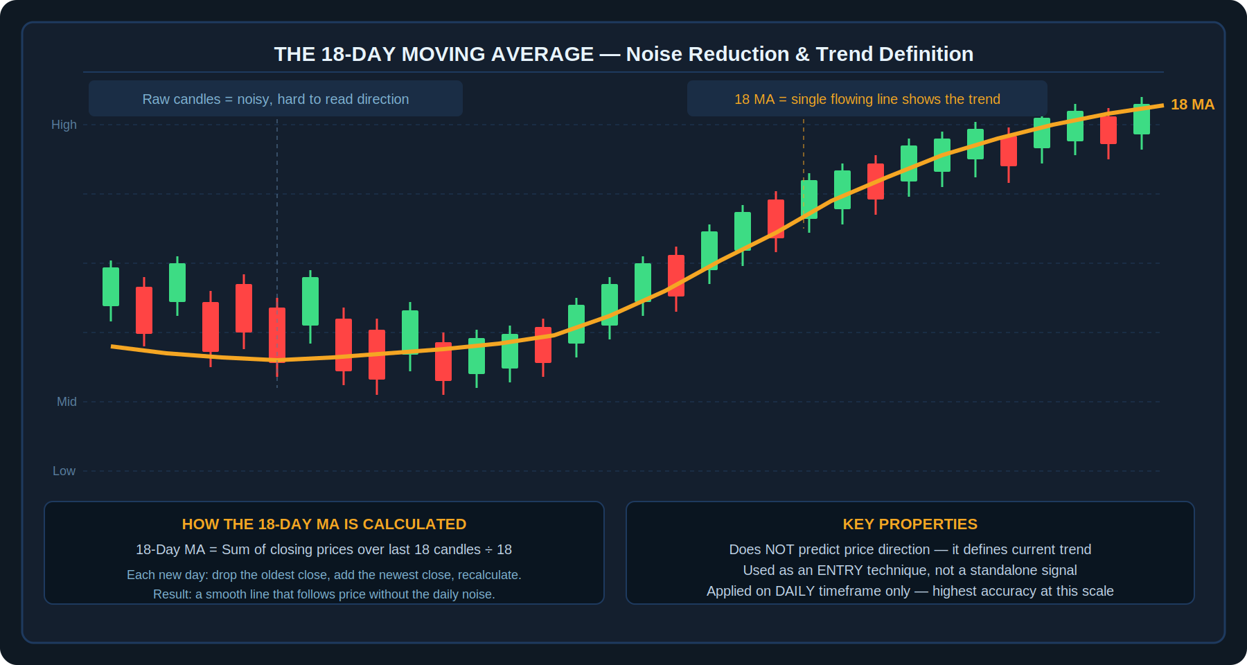
Diagram 1 — The 18-Day MA as a noise-reduction and trend-definition tool: raw candles vs the smooth 18-day MA line
💡 | The 18-day MA does not predict price direction — it defines the current trend and provides a reference level from which qualified entries are timed. It is an entry technique, not a standalone trading system.

2. Core Principles
Before applying the strategy, these foundational principles must be understood. They define the conditions under which the 18-day MA strategy performs at its highest reliability:

Five Core Principles
- Look for qualified breakouts that have an accumulation or distribution pattern behind them — a tight consolidation zone before the move. Good risk/reward ratio requires this setup.
- The moving average does not move the market. It should be used only as an entry technique, not as a primary market signal.
- This strategy performs best in markets that have a strong fundamental setup — price action alone is not sufficient. The fundamental backdrop must support the directional bias.
- Apply the strategy on the daily timeframe only. Lower timeframes reduce accuracy significantly.
- The 18-day MA delivers its highest accuracy when all conditions align: fundamental setup, accumulation/distribution zone, OBV confirmation, and the two qualifying days.

3. The Buy Setup (Long Entry)
The buy setup requires the market to demonstrate buyer conviction through an accumulation phase before the 18-day MA is used to time entry. Entering without a prior accumulation zone significantly reduces the probability of success.

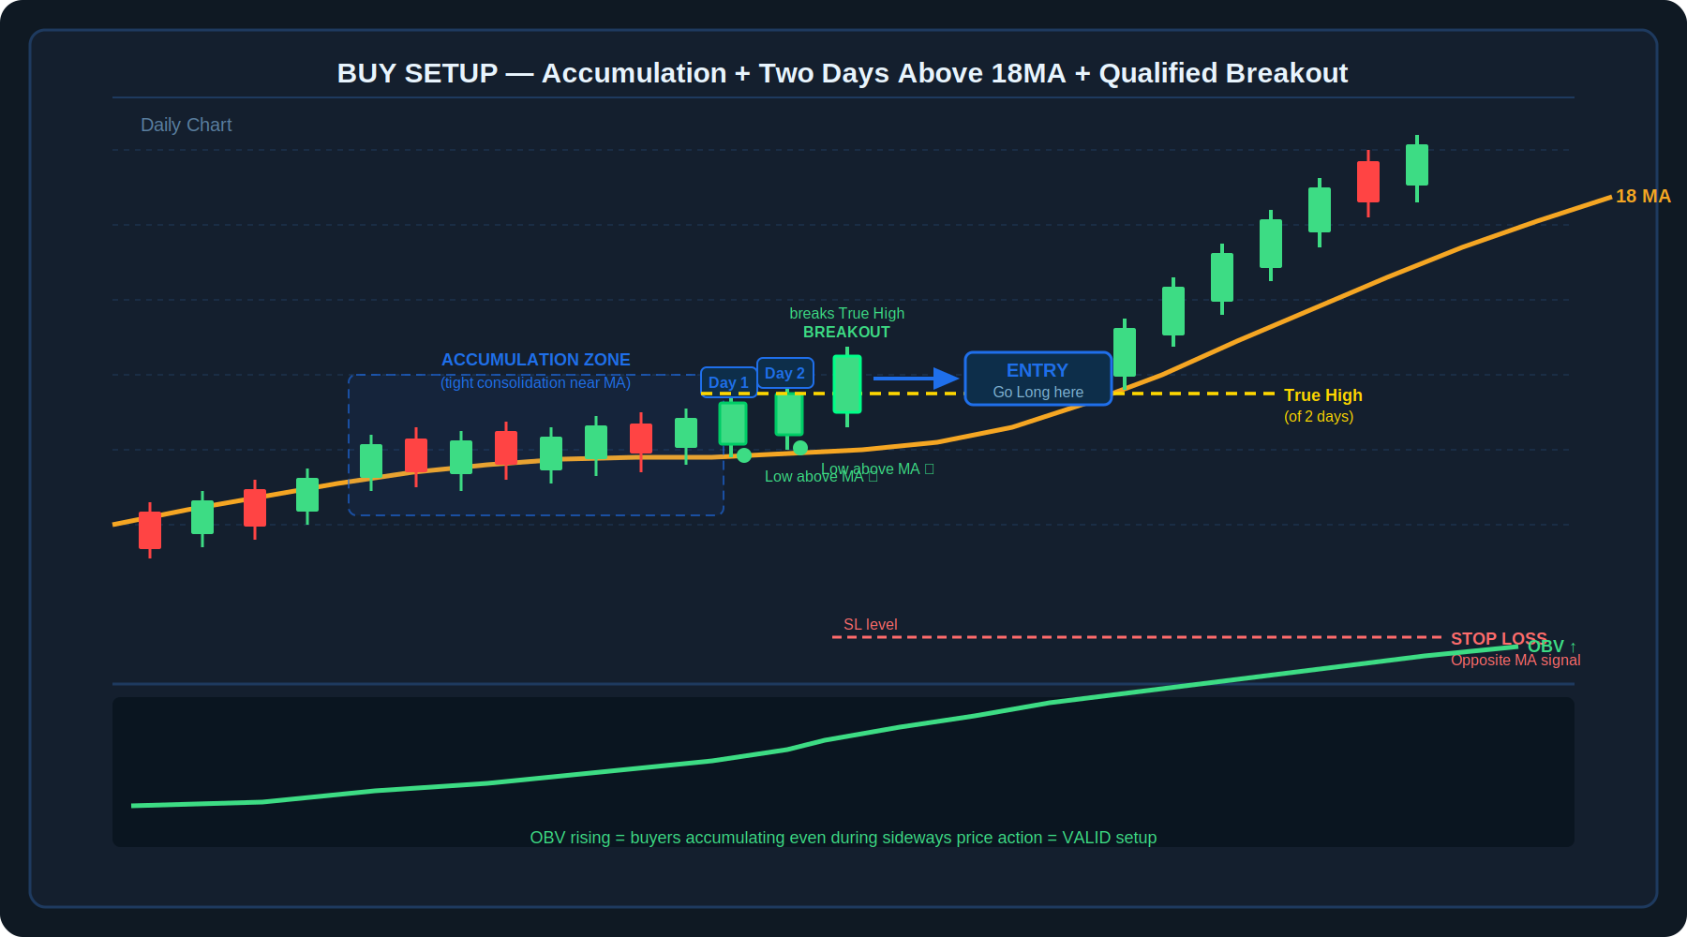
Diagram 2 — Buy Setup: Accumulation zone with rising OBV, two days with lows above 18MA, breakout above the true high with entry

3.1 What is Accumulation?
Accumulation is a market condition where buyers are consistently willing to purchase at or near resistance — even when price appears to be going nowhere. It shows up as a tight sideways zone where price does not break down, despite multiple attempts. The key evidence for accumulation is found in the On Balance Volume (OBV) indicator: if OBV is rising while price consolidates, buyers are quietly building positions. This is the required context for the buy setup.

3.2 The Two Qualifying Days
Once an accumulation zone is confirmed, the strategy requires two specific days to form before entry is considered. These are the structural trigger of the buy setup:

- Day 1: A daily candle whose LOW is above the 18-day MA. This means the MA is below the day's entire range — price did not dip to or below the MA at any point during the session.
- Day 2: A second consecutive (or near-consecutive) daily candle whose LOW is also above the 18-day MA.
- Both days must form within the context of the accumulation zone — not randomly in a trending or volatile market.

3.3 The Qualified Breakout Entry
Once the two qualifying days are in place, the entry level is defined as the true high of those two days combined — the highest high reached across both days. The trade is entered when price breaks above this level on the third day. If the market does not break above the true high, there is no trade.

Buy Setup — Step-by-Step Rules
- Confirm a fundamental setup exists that supports a rally in this market.
- Identify an accumulation zone: a tight, sideways consolidation near resistance where price is holding up.
- Verify accumulation using OBV: OBV should be rising or flat-to-rising during the consolidation period.
- Wait for Day 1: a daily candle whose LOW is above the 18-day MA.
- Wait for Day 2: another daily candle whose LOW is also above the 18-day MA.
- Mark the True High of those two days (the highest high across both sessions).
- Enter LONG when the next day's price breaks above the True High of the two qualifying days.
- No breakout above the True High = No trade. Do not anticipate the break.
- Stop loss: placed at the level where the 18-day MA forms an opposite signal — a bearish cross or opposite structure on the chart.

📌 | The OBV rising during a tight consolidation zone is one of the most reliable indicators of accumulation. It shows that volume is flowing in on up days even when price appears flat — institutional buying without driving price up prematurely.

4. The Sell Setup (Short Entry)
The sell setup is the exact mirror of the buy setup. Instead of accumulation, the market must first show a distribution phase — a tight consolidation where sellers are progressively offloading positions before a breakdown.

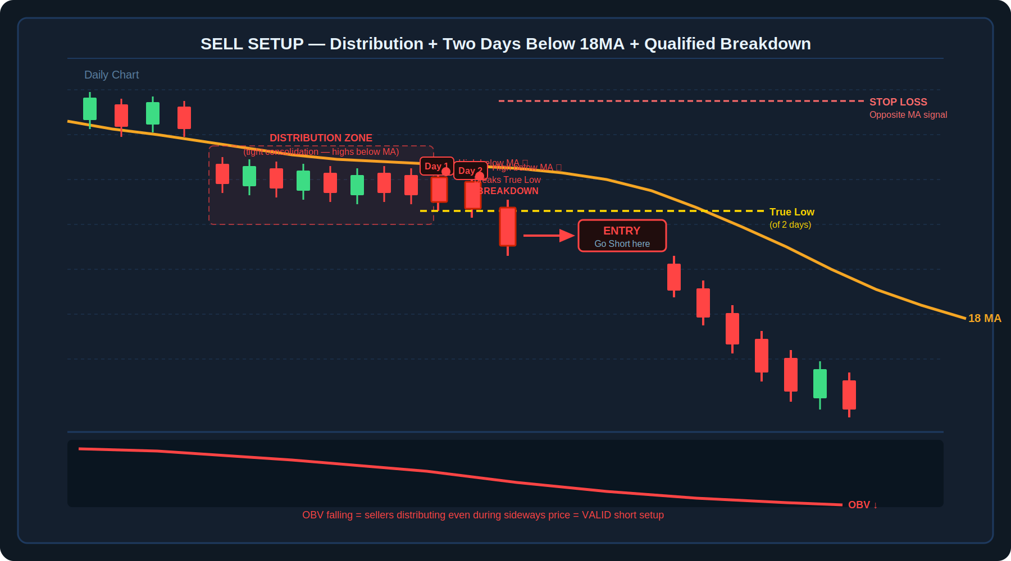
Diagram 3 — Sell Setup: Distribution zone with falling OBV, two days with highs below 18MA, breakdown below the true low with entry

4.1 What is Distribution?
Distribution is the opposite of accumulation. It occurs when sellers are willing to sell even at support levels, preventing any meaningful rally. The market consolidates in a tight range, but sellers are steadily building short positions. OBV declining during a sideways phase is the primary evidence of distribution — volume is flowing out on down days while price appears stable.

Distribution can also be identified using Wyckoff pattern analysis, which describes the stages of large-scale institutional distribution before a decline.

4.2 The Two Qualifying Days
Just as the buy setup requires two days with lows above the 18MA, the sell setup requires two days with a specific structural characteristic:

- Day 1: A daily candle whose HIGH is below the 18-day MA. The MA is above the candle's entire range — price could not rally above the MA during the session.
- Day 2: A second daily candle whose HIGH is also below the 18-day MA.
- Both days must form within the context of the distribution zone, not randomly in a declining trend.

4.3 The Qualified Breakdown Entry
The entry level is the true low of the two qualifying days — the lowest low across both sessions. A short position is entered when price breaks below this level. If price does not break the true low, no trade is taken.

Sell Setup — Step-by-Step Rules
- Confirm a fundamental setup exists that supports a decline in this market.
- Identify a distribution zone: a tight sideways consolidation near support where price is failing to rally.
- Verify distribution using OBV: OBV should be declining or flat-to-declining during the consolidation period.
- Wait for Day 1: a daily candle whose HIGH is below the 18-day MA.
- Wait for Day 2: another daily candle whose HIGH is also below the 18-day MA.
- Mark the True Low of those two days (the lowest low across both sessions).
- Enter SHORT when the next day's price breaks below the True Low of the two qualifying days.
- No breakdown below the True Low = No trade. Do not anticipate the break.
- Stop loss: placed at the level where the 18-day MA forms an opposite signal on the chart.

⚠️ | The stop loss for both setups is defined by the formation of an opposite signal on the 18-day MA. This is not a fixed-point stop — it is a structural stop based on the MA's relationship with price. When the MA signals the opposite direction, the original trade thesis is invalidated.

5. The Fundamental Filter — Why It Matters
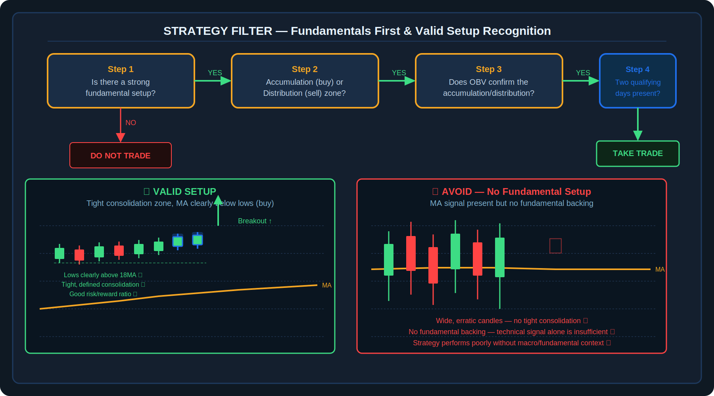
Diagram 4 — Fundamentals-first decision flow and valid vs invalid setup comparison
The 18-day MA strategy is explicitly designed to work best when there is a strong fundamental setup behind the market's direction. This is not a pure technical system — it is a technical entry method within a fundamentally-driven framework.

Using the strategy in markets with no fundamental backing — where price is moving solely on technical or random factors — significantly reduces accuracy. The strategy's edge comes from aligning the technical entry signal (the qualified breakout or breakdown) with a market where the underlying supply and demand dynamics already favour the direction of the trade.

5.1 What Constitutes a Fundamental Setup?
A strong fundamental setup means there is a real-world reason for the market to move in the anticipated direction — supply disruptions, demand shifts, policy changes, seasonal patterns, or macro conditions that align with the technical signal. The technical signal (two qualifying days + breakout/breakdown) times the entry. The fundamental context determines whether the trade is worth taking in the first place.

🔑 | A good risk/reward ratio requires both a tight consolidation zone (which limits the stop loss distance) and a fundamental reason for the market to move (which supports a large target). Without the fundamental setup, the stop loss may be tight but the market has no reason to reach the target.

5.2 The Complete Setup Filter
Condition | Required for Buy | Required for Sell
Fundamental backdrop | Bullish fundamental setup | Bearish fundamental setup
Consolidation zone type | Accumulation (tight, near resistance) | Distribution (tight, near support)
OBV confirmation | Rising OBV during consolidation | Declining OBV during consolidation
Day 1 condition | Low above 18-day MA | High below 18-day MA
Day 2 condition | Low above 18-day MA | High below 18-day MA
Entry trigger | Break above True High of Day 1 & 2 | Break below True Low of Day 1 & 2
Stop loss | Opposite 18MA signal below entry | Opposite 18MA signal above entry

6. Pre-Trade Checklist

Buy Setup Checklist
✓ | Checklist Item
☐ | A strong fundamental setup exists that supports a rally — I have identified what it is before looking at the chart
☐ | An accumulation zone is visible: a tight, sideways consolidation where price is holding near resistance without breaking down
☐ | OBV is rising or flat-to-rising during the consolidation period, confirming buyers are active
☐ | Day 1 has formed: a daily candle whose LOW is above the 18-day MA
☐ | Day 2 has formed: another daily candle whose LOW is also above the 18-day MA
☐ | The True High of those two days is marked on the chart
☐ | Price has broken above the True High — entry is placed at this break
☐ | Stop loss is placed at the level where the 18MA would form an opposite signal
☐ | Risk/reward ratio is acceptable given the distance to the identified target

Sell Setup Checklist
✓ | Checklist Item
☐ | A strong fundamental setup exists that supports a decline — I have identified what it is before looking at the chart
☐ | A distribution zone is visible: a tight, sideways consolidation where price is failing to rally near support
☐ | OBV is declining or flat-to-declining during the consolidation period, confirming sellers are active
☐ | Day 1 has formed: a daily candle whose HIGH is below the 18-day MA
☐ | Day 2 has formed: another daily candle whose HIGH is also below the 18-day MA
☐ | The True Low of those two days is marked on the chart
☐ | Price has broken below the True Low — short entry is placed at this break
☐ | Stop loss is placed at the level where the 18MA would form an opposite signal
☐ | Risk/reward ratio is acceptable given the distance to the identified target

7. Key Terms
Term | Definition
18-Day Moving Average (18MA) | A simple moving average calculated by summing the last 18 daily closing prices and dividing by 18. Updates with each new day by adding the latest close and removing the oldest.
Moving Average (MA) | An indicator that calculates the average price over a given period. Smooths out day-to-day volatility to reveal the underlying trend direction.
Noise | Short-term, random price fluctuations on a chart that make trend identification difficult. The 18MA filters noise by averaging prices over 18 days.
Accumulation Zone | A period of tight sideways price action near resistance where buyers are quietly building long positions, often confirmed by rising OBV. A prerequisite for the buy setup.
Distribution Zone | A period of tight sideways price action near support where sellers are offloading positions, confirmed by declining OBV. A prerequisite for the sell setup.
OBV (On Balance Volume) | A momentum indicator that adds volume on up days and subtracts volume on down days. A rising OBV during a consolidation signals accumulation; declining OBV signals distribution.
Qualified Breakout | A breakout that occurs after a valid accumulation/distribution zone and two qualifying days above/below the 18MA, not a random move. "Qualified" means all conditions are met.
Two Qualifying Days (Buy) | Two consecutive or near-consecutive daily candles whose LOWS are both above the 18-day MA. Required before a long entry is considered.
Two Qualifying Days (Sell) | Two consecutive or near-consecutive daily candles whose HIGHS are both below the 18-day MA. Required before a short entry is considered.
True High | The highest high reached across the two qualifying days in the buy setup. Entry is triggered when this level is broken to the upside.
True Low | The lowest low reached across the two qualifying days in the sell setup. Entry is triggered when this level is broken to the downside.
Opposite Signal (Stop Loss) | The condition where the 18-day MA produces a signal in the opposite direction of the trade — used as the structural stop loss level for both buy and sell setups.
Fundamental Setup | A real-world supply/demand, macro, or policy condition that supports the direction of the trade. Required before any technical entry is considered in this strategy.
Wyckoff Pattern | A framework for identifying accumulation and distribution phases based on the interaction between price, volume, and time — used as an alternative or complement to OBV for confirming distribution in sell setups.
Risk/Reward Ratio | The relationship between the potential loss (distance to stop) and potential gain (distance to target). The 18MA strategy seeks a favourable ratio by requiring tight consolidation zones that naturally limit stop distance.

Disclaimer
This document is produced solely for educational and informational purposes. The strategy described herein is based on publicly available research and is presented as a learning framework only. It does not constitute financial advice, a recommendation to trade, or a guarantee of any specific outcome. Trading in financial markets involves substantial risk of loss. Always conduct your own due diligence, backtest any strategy thoroughly, and consult a qualified financial adviser before committing real capital.

